Lunch Menu

Mains
- Vegetable frittata served with
garlic bread & salad (V)
Allergens – Milk, egg & wheat

Pudding
- Banana upside down cake served with ice cream (V)
Allergens – wheat, milk, soya & egg
or
Fruit of the day
or
Sugar free jelly or (V)
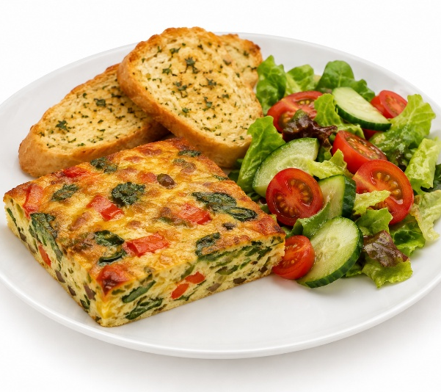 | Vegetable frittata served with garlic bread & salad (V)
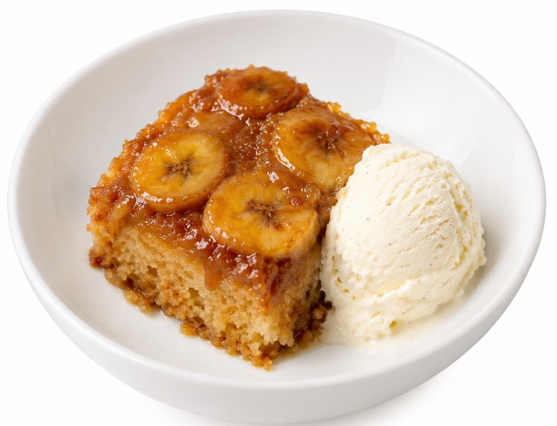 | Banana upside down cake served with ice cream (V)  or  Fruit of the day  or  Sugar free jelly

