Lunch Menu
Mains
- Roasted salmon & vegetables
served with roasted potatoes
Allergens – Fish, mushroom

Vegetarian
- Feta cheese, chickpea & vegetables served with roasted potatoes
Allergens – Milk, chickpea & mushroom
or
- Three beans salad (V)
Allergens – Mustard & sulphite

Pudding
- Pear & ginger cake
served with cream or
Allergens – Wheat, egg & milk
Fruit of the day or sugar free jelly
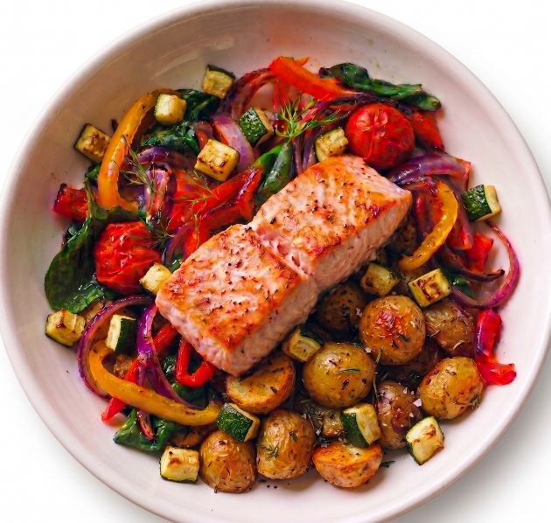 | Roasted salmon & vegetables served with roasted potatoes
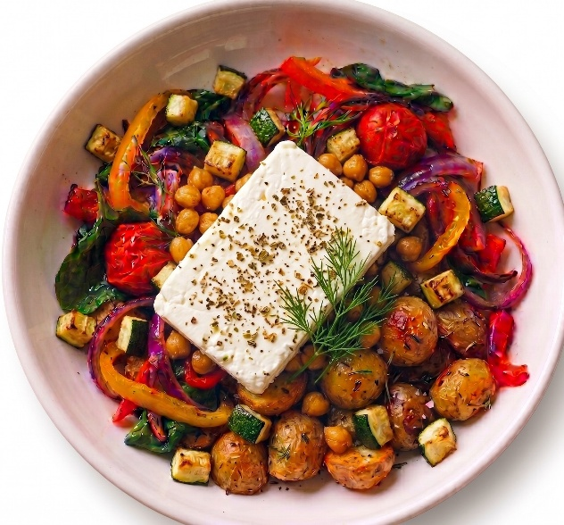 | Feta cheese, chickpea & vegetables served with roasted potatoes (V)
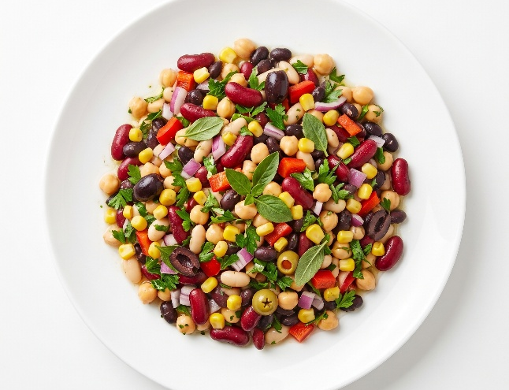 | Mixed bean salad (V)

