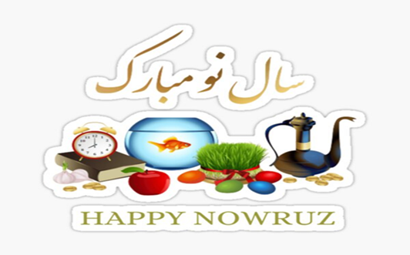
Day Opportunities Daily Planner
Persian New Year Nowruz & Eid Mubarak Week

Date 25/03/2026
Time | Activity
10:00 – 11:00 | Tea & Coffee Morning
11:00 – 12:00 | Group 1  Crafting  Making a spring flower wreath/  Goldfish | Group 2  Baking Afghan cookies (Kulcha)  Spring word search
12:00 - 12:30 | Group 1  Seated yoga | Group 2  Cognitive stimulation
12:30 - 13:30 | Lunch
13:30 - 14:30 | Group 1  Discussion about the Persian  New Year & Eid/ Finish the common phrase | Group 2  Spring blossom painting
14:30 - 15:00 | Enjoy the Afghan cookies/ Birthday celebration

