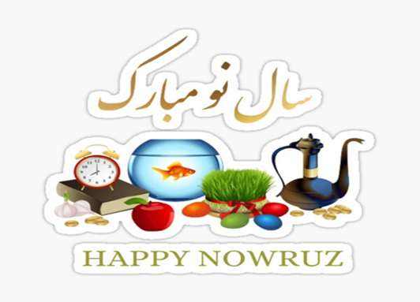
Day Opportunities Daily Planner
Persian New Year Nowruz & Eid Mubarak Week

Date 26/03/2026
Time | Activity
10:00 – 11:00 | Tea & Coffee Morning
11:00 – 12:00 | Group 1  Crafting:  Making a spring flower wreath/  Goldfish | Group 2  Discussion about the Persian  New Year/ Eid & Word game
12:00 - 12:30 | Group 1  Yoga with Ros | Group 2  Cognitive Stimulation
12:30 - 13:30 | Lunch
13:30 - 14:30 | Group 1  Finish the common phrase | Group 2  Spring blossom painting
14:30 - 15:00 | Enjoy the Music

