Lunch Menu
Mains
- Chicken stroganoff served with
broccoli & rice
Allergens – Celery, mustard,
sulphite, milk & mushroom
Vegetarian
- Quorn stroganoff served with broccoli & rice (V)
Allergens – Egg, mustard, milk, soya,
celery, sulphite & mushroom
or
- Couscous & egg salad (V)
Allergens – Wheat, egg, mustard & sulphite
Pudding
- Cherry pie served with ice cream
Allergens – Wheat, egg, milk & soya
or
Fruit of the day or sugar free jelly
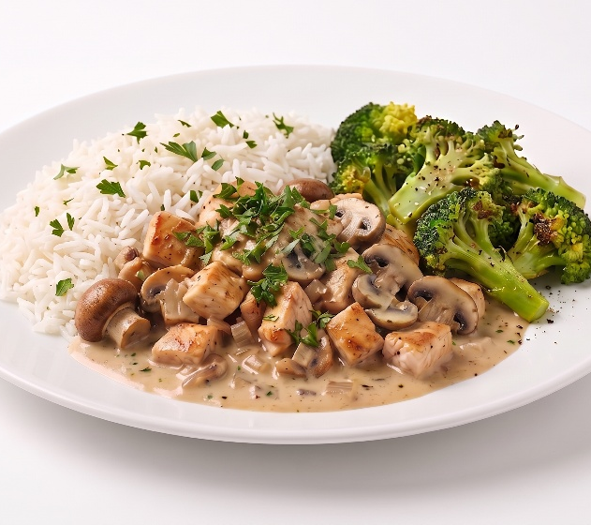 | Chicken stroganoff served with broccoli & rice
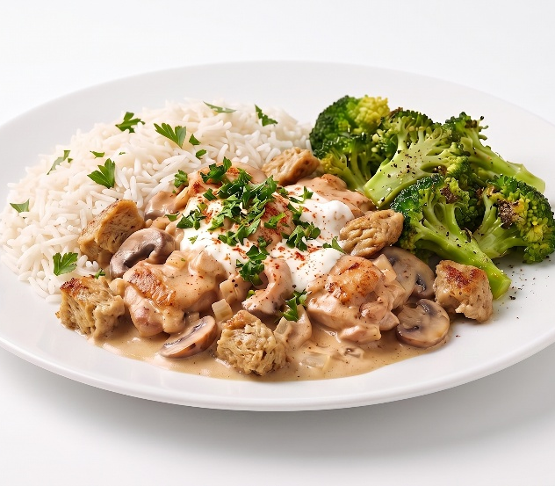 | Quorn stroganoff served with broccoli & rice (V)
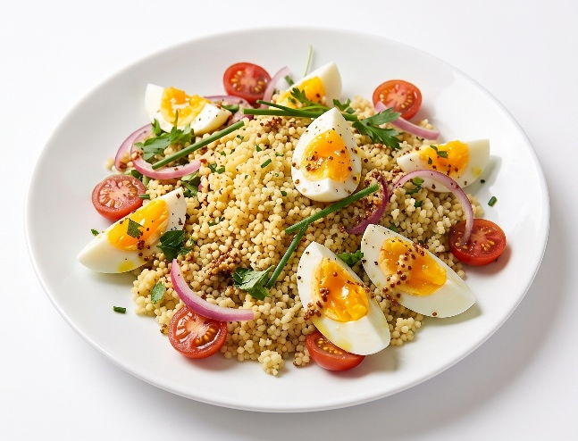 | Couscous & egg salad (V)

