Lunch Menu
Mains
- Turkey meatballs served with tomato sauce, rice & broccoli
Allergens – Celery & sulphite
Vegetarian
- Vegetarian Quorn balls served with tomato sauce, rice & broccoli (V)
Allergens – Celery, barley, egg & wheat
or
- Spinach & cheese omelette served with salad & garlic bread (V)
- Allergens – Wheat, egg, milk,
mustard & sulphite
Pudding
Bramley apple pie
served with custard (V) or
Allergens – wheat, egg, milk & sulphite
Fruit of the day or Sugar free jelly
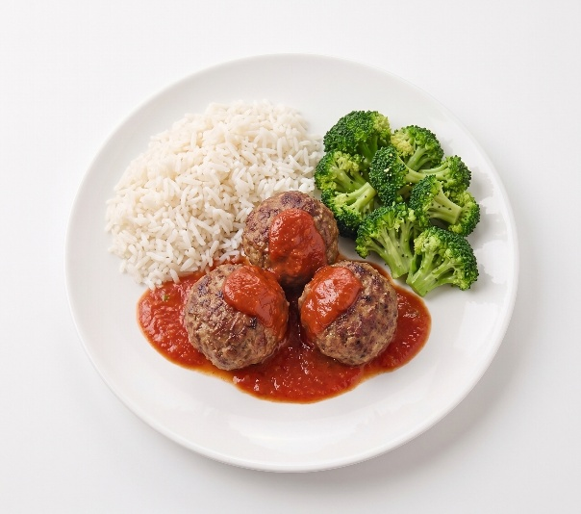 | Turkey meatballs served with tomato sauce, rice & broccoli
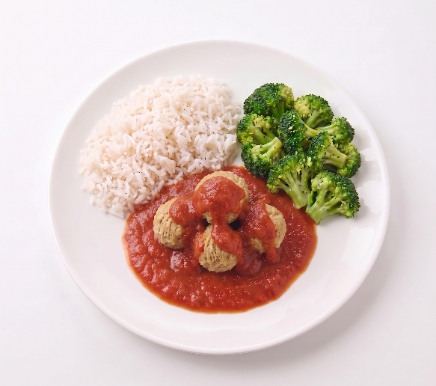 | Vegetarian Quorn balls served with tomato sauce, rice & broccoli (V)
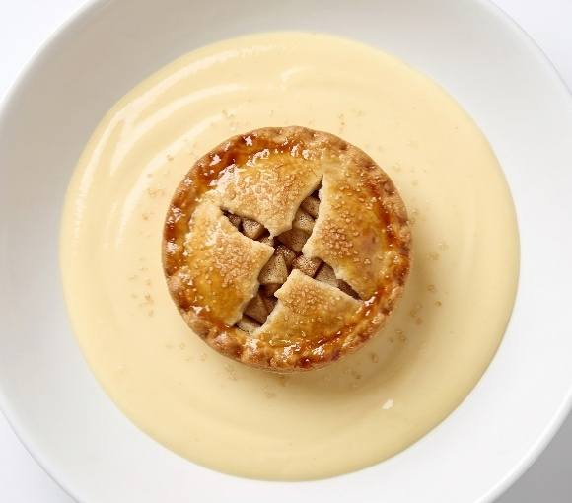 | Bramley apple pie  served with custard (V) or  Fruit of the day  or  Sugar free jelly

