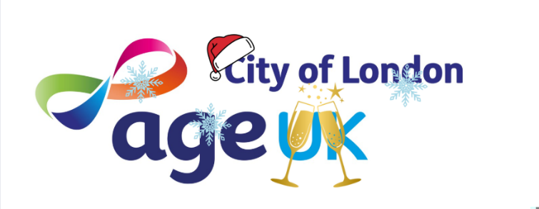

Christmas closures and New Year opening 26

Mondays 10.30-11.30am  Last class 15th Dec, returns 5th Jan | Women only Zumba | Portsoken Community Centre E1 8AH | Gentle Zumba class for women 55+
Mondays 2.15-4pm  Open every week throughout Christmas period | Golden Social | Golden Lane Community Centre, Fann St EC1Y 0RD | Tea, coffee, chat, board games, crafts, films, visiting speakers
Tuesdays 10.30-11.30am  Last walk 16th Dec,  returns 6th Jan | Very gentle health walk  (for Square Mile Health Walks see Walks Programme) | Meet by Giddy Up Coffee, Fortune Street Park EC1Y 0SB | A social walk to improve confidence, balance and stability. Tea & coffee to finish
Tuesdays 5.30-7pm  Last session 16th Dec, returns 6th Jan | Digital Support | Barbican Library,  Barbican Centre  EC2Y 8DS | Bring along your phone or tablet to get help with using it.
Wednesdays  2-4pm  Last session 17th Dec, returns 14th Jan | Textile Crafts/  Knit and Natter (fortnightly on Wednesdays) | Artizan Library  Artizan St  E1 7AF | Textile-based crafts including knitting, crochet, sewing etc
Wednesdays  4-5pm  Last class 17th Dec, returns 7th Jan | Movement to Music | Portsoken Community Centre | A fun, active fitness class for women 55+
Fridays  10-11am  Last class 19th Dec, returns 9th Jan | Chair yoga  online class | Zoom | A friendly online class. Contact Alice for joining details
Fridays 2.15-3.15pm  Last class 19th Dec, returns 9th Jan | Tai Chi | Golden Lane Community Centre | Tai Chi for people aged 55+

For more info email Alice.Westlake@AgeUKCityofLondon.org.uk
or call 0203 488 6884 (Mon-Thurs)

Web: www.ageukcityoflondon.org.uk
Calendar December 25:

When | What | Where | How
Mon 1st Dec  2.15-4pm | Golden Social: Coffee, chat, Scrabble | Golden Lane Community Centre | Just turn up
Tues 2nd Dec  1.30-3.30pm | Digital support 1:1s | Golden Lane Community Centre | Please contact Nik on the details below
Wed 3rd Dec  2-4pm | Knit and Natter | Artizan Library | Just turn up
Thurs 4th Dec  2-4pm | Square Mile Health walk:  Monument to The George Southwark | Meet at Monument tube | Just turn up  Prompt 2pm start
Sat 6th Dec  11am-12 noon | Square Mile Health walk:  St Pauls circular | Meet at St Pauls tube, outside Café Nero | Just turn up  Prompt 11am start
Mon 8th Dec  10.30am-12 noon | Art Discussion group | Zoom | Just log in  Meeting ID: 849 376 2063  Passcode: hello
Mon 8th Dec  2.15 – 4pm | Golden Social: London Museum workshop  Stencil printing – make your own London Museum tea towel. | Golden Lane Community Centre | 12 places available for printing workshop.  Just turn up for coffee chat and Scrabble.
Tues 9th Dec  1.30-3.30pm | Digital support 1:1s | Golden Lane Community Centre | Please contact Nik on the details below
Mon 15th Dec  2-4pm | Golden Social: CHRISTMAS PARTY  Refreshments and live music! | Golden Lane Community Centre | Just turn up, all welcome
Tues 16th Dec  1.30-3.30pm | Digital support 1:1s | Golden Lane Community Centre | Please contact Nik on the details below
Wed 17th Dec  2-4pm | Knit and Natter Christmas tipple  If you’ve attended the group this year, come and toast to future projects | Artizan Library | Just turn up
Thurs 18th Dec  1-3pm | Amazon Audible Christmas celebration | Glasshouse Yard | By invitation only
Sun 21st Dec  10am-12pm | Square Mile Health walk:  St Pauls to Tower Hill | Meet at St Pauls tube, outside Café Nero | Just turn up  Prompt 10am start
Mon 22nd Dec  2-4pm | Golden Social: film – Click and Collect | Golden Lane Community Centre | Just turn up
Mon 29th Dec  2.15-4pm | Golden Social: Coffee, chat, Scrabble | Golden Lane Community Centre | Just turn up
Wed 31st Dec  2-5pm | New Years Eve party  Tudor Rose Court and Age UK City of London are having a joint New Years celebration with live music from Guildhall students. RSVP essential. | Tudor Rose Court, Fann Street | Contact Alice to book a place

Email Alice: alice.westlake@ageukcityoflondon.org.uk
Email Nik: digitalsupport@ageukcityoflondon.org.uk

