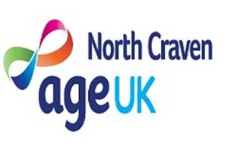

Warm and Well North Yorkshire
This support is available for any North Yorkshire County Council resident.

Are you worried about somebody who:
- Can't afford high fuel and energy bills
- Looking for advice/support to switch Energy Supplier
- Feels lonely or isolated,
- Is cold at home which is making them unwell,
- Cannot keep warm at home because of problems with heating cold and damp conditions
- Would like general information on staying warm and well, or related events, training, or resources.
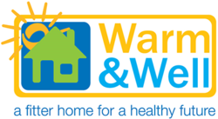
Click HERE for information and referrals

