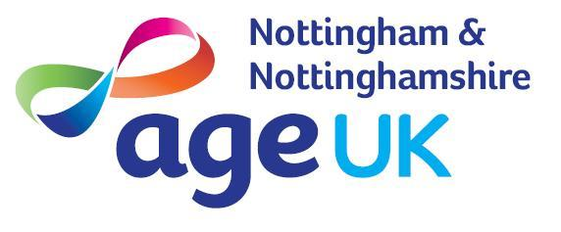
Equal Opportunities Recruitment Monitoring Form

Age UK Nottingham & Nottinghamshire Equality & Diversity Policy

Our Equality & Diversity Policy is stated overleaf and in order that it is effective we need to obtain certain information, which will allow us to evaluate how successful our effectiveness as an equal opportunities employer has been. It is for this reason that we would like you to fill in this monitoring form and Age UK Notts can confirm that this data will not be used to shortlist and is kept confidential and separate from your application. You are under no obligation to complete this form.
I understand that this information may be held electronically and/or on paper file. We will store this information securely and act in accordance with current Data Protection Law and our Privacy Statement. Age UK Notts may hold and use personal information about you for monitoring purposes only. Any information provided on this form will be treated as strictly confidential and no information will be published or used in any way which allows any individual to be identified.

Position Applied for: _______________________________________

Date of Birth:
Age:
Sex: | Man | Woman |  | Non-binary |  | Prefer not to say
Gender Identity: | Is your gender identity the same as the gender you were assigned at birth?
 | Yes |  | No |  | Prefer not to say
Are you married or in a civil partnership? | Yes |  | No |  | Prefer not to say

How would you describe your ethnic or cultural origin?
Arab |  | Mixed - White and Black Caribbean
Asian or Asian British - Bangladeshi |  | Mixed – Other Mixed Background
Asian or Asian British - British |  | White - British
Asian or Asian British - Chinese |  | White - English
Asian or Asian British - Indian |  | White - Gypsy and Traveller
Asian or Asian British - Pakistani |  | White - Irish
Asian or Asian British - Other Asian Background |  | White - Northern Irish
Black or Black British - African |  | White - Scottish
Black or Black British - British |  | White - Welsh
Black or Black British - Caribbean |  | White - Other White Background
Black or Black British - Other Black Background |  | Prefer not to say
Chinese or Chinese British |  | Other, please specify
Mixed – White and Asian
Mixed – White and Black African

Do you consider yourself to have a disability?
No |  | Please tick if you have a Blue Badge
Yes |  | Prefer not to say
If yes, what is the nature of your disability? _______________________________________
__________________________________________________________________________
__________________________________________________________________________

Please tick the option which best describes your religion or belief:
Atheism |  | Judaism
Baha |  | None
Buddhism |  | Rastafarianism
Christianity |  | Sikhism
Hinduism |  | Prefer not to say
Islam (Muslim) |  | Other, please specify
Jainism

How would you describe yourself?
Bisexual |  | Prefer not to say
Gay woman/lesbian |  | Other, please specify
Heterosexual /Straight
Gay man/homosexual

Do you have caring responsibilities? If yes, please tick all that apply.
None |  | Primary carer of older person (65+)
Primary carer of a child/children (under 18) |  | Secondary carer
Primary carer of a disabled child/children |  | Prefer not to say
Primary carer of disabled adult (18⁺) |  | Other, please specify:

What is your area of residence?
Ashfield |  | Newark & Sherwood
Bassetlaw |  | Nottingham City
Broxtowe |  | Rushcliffe
Gedling |  | Prefer not to say
Mansfield |  | Other, please specify:

The replies provided on this form will not be used for any purpose other than monitoring. By completing this form you have helped us better understand how we, as an employer, ensure equality of opportunity for all

Thank you for your participation!

