Nutrition and Hydration Week 2024
Social Media Pack
The Greater Manchester Nutrition and Hydration team are promoting the UK’s 12th Nutrition and Hydration Week and we need your help! As one of our partners, we are asking you to help us get the messages out about good nutrition and hydration in later life.
We have made 7 social media posts which are ready to use, one for each day of the week. Please post on each day with the image, hashtags and tags we have prepared for you.
You can post these on your Twitter page, Facebook page or both. To make it easier, you can schedule the posts to go out in advance when it suits you.
A simple action like this can really save and improve the lives of many older people living in the UK by busting myths and spreading the right messages about eating and drinking well in later life.
Thank you,
The Greater Manchester Nutrition and Hydration Team

Post 1- to be posted on Monday 11th March 2024

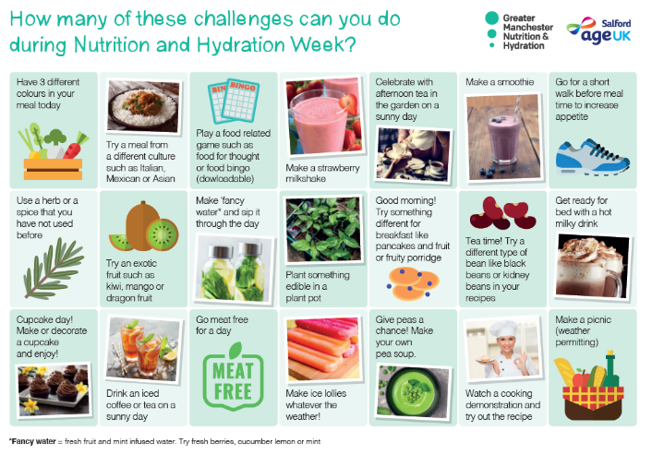

Magnificent Monday- UK’s 12th N&H week is here! Help us celebrate good Nutrition and Hydration by sharing our messages and have a go at our challenge calendar this week! #challenge #NHWeek2024 @NHWeek @GMNandH

Post 2 – to be posted on Tuesday 12th March 2024

Taste Testing Tuesday! Trying new foods is a great way to increase variety in your diet- why not try something from a different culture you have not tried before? You might even find a new favourite! #trysomethingnew #NHWeek2024 @NHWeek @GMNandH

Post 3 – to be posted on Wednesday 13th March 2024

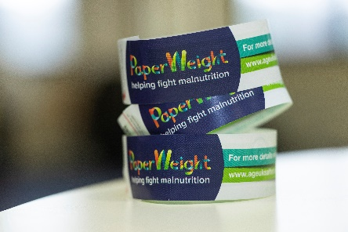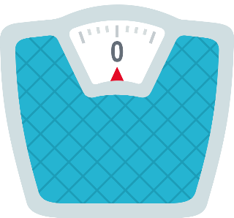
Weigh in Wednesday- Keeping an eye on you or loved one’s weight as they get older can prevent any unplanned weight loss which can be the first sign of malnutrition. If you don’t have scales, you can use the @PArmband or watch for visual signs, such as loose clothing @NHWeek202 @GMNandH

Post 4 – to be posted on Thursday 14th March 2024
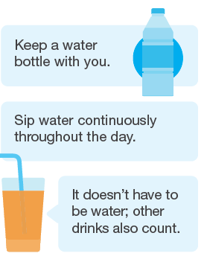
Thirsty Thursday! Did you know that you need 6-8 drinks per day to stay well hydrated? Dehydration can cause infections and falls and sipping fluids throughout the day can help prevent these. #NHWeek2024 #ButFirstaDrink @NHWeek @GMNandH

Post 5 – to be posted on Friday 15th March 2024
It’s a Fruity Friday! Did you know that fruits are an excellent source of vitamins, minerals, fibre and water? Have an extra piece of fruit today and why not try a new type you have not had before? #trysomethingnew #NHWeek2023 @NHWeek @GMNandH

Post 6- to be posted on Saturday 16th March 2024

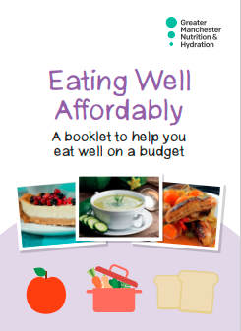

The #CostOfLiving doesn’t need to stop you or someone you look after from eating well. We have collated our best tips on eating well on a #budget. You can download it for free on our website eating-well-affordably-pdf.pdf (ageuk.org.uk) #NHWeek2024 @NHWeek @GMNandH

Post 7- to be posted on Sunday 17th March 2023
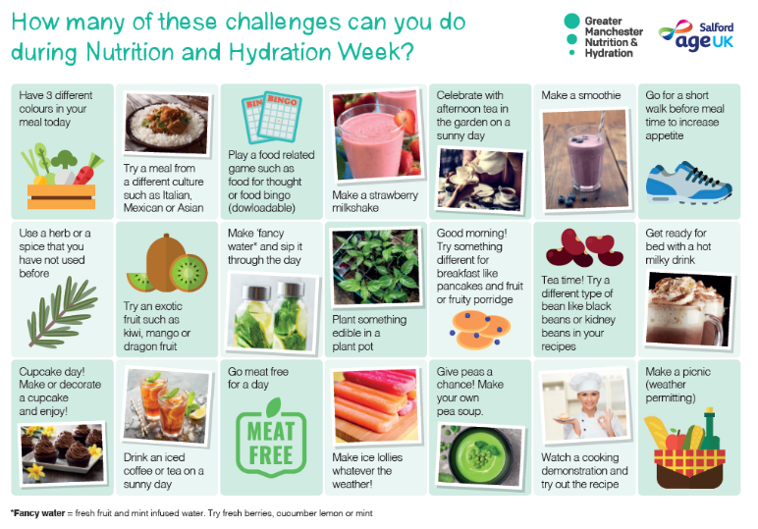

Did you or someone you look after use this week to try new habits in order to eat and drink well? If so, we would love to hear from you and if it made any difference! Comment below! And thank you for helping us promote good nutrition and hydration messages during this past week #nutritionmatters #challenge #NHWeek2024 @NHWeek @GMNandH

__________________________________________________________________

