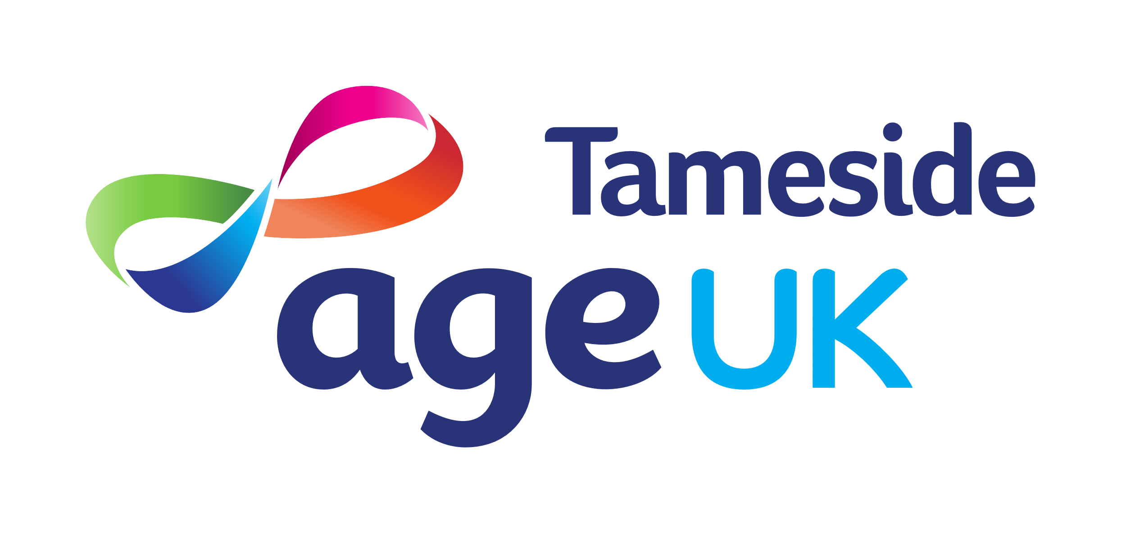
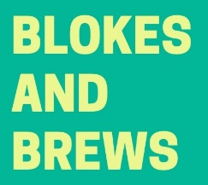

BLOKES AND BREWS REGISTRATION FORM

Full Name
Address |  | Do you live alone Y/N
Your Age |  | Are you a carer Y/N
Best Contact Number
Email Address
Emergency Contact

Do you have any of the following health issues (PLEASE TICK):

Diabetes
COPD
Asthma
Hypertension
Arthritis
Mental Health
Mobility Needs

Other (please detail):
Tell us what you would like to achieve from the group? (PLEASE TICK):

Meet new people
Make new friends
Feel less lonely
Try new activities
Do activities I enjoy
Build my confidence

We will ask you about this again at some point during your time with the group or afterwards by telephone.

I consent to the safe storage of my information and consent to be contacted about the group:

Signed:

Date:

