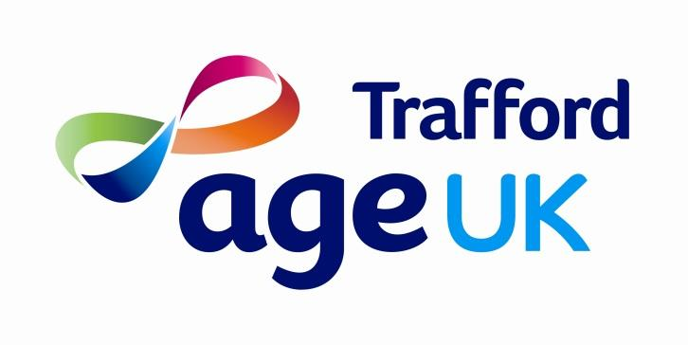

Strategy Document 2022-2026

Mission Statement:

“Age UK Trafford exists to work in partnership with and to empower Trafford residents to lead an active and fulfilling later life; and to provide high-quality accessible services, listening to and respecting the views of all”

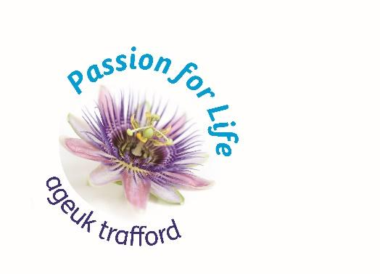

Age UK Trafford is a local independent charity for people over 50’s.
We have supported people in Trafford since 1975. We work only in Trafford and rely on local funding, fundraising and donations to provide each individual service and activity.
Our Vision
The vision that shapes our activities is a Trafford where every person over 50 is treated with respect and is supported to make the most of later life meeting their needs and aspirations.
Our Values
Our organisation is guided by the following values:
- People over 50, and their carers, are at the centre of everything we do
- We are committed to the best possible support for people with dementia and their carers
- We value and respect our volunteers, supporters and staff
- We are committed to providing the highest quality of services
- We are committed to helping combat climate change
- We are committed to reduce health inequalities
- We strive to add social value to everything we do
- We are passionate, open and honest.

Our Strategic Aims
The strategic aims employed to achieve the charity’s objectives are:
- We will significantly increase awareness of our work to reach out to more local people and to promote the positive contribution people over 50 can make to their community

- As the leading Trafford provider in dementia care, we will deliver high quality support to improve the lived experience of the person with dementia and their carers

- We will help people over 50 in Trafford to make informed choices about their health and wellness and the services and support they need

- We will support people over 50 in Trafford to feel valued and included in their community

- We will work in partnership with a range of statutory, third sector and private sector partners to improve the lived experience of people over 50 in Trafford and to share good practice and expertise

- We will work with a wide range of partners to help reduce health inequalities in Trafford

- We will support people over 50 in Trafford, who struggle financially, out of poverty

- We will be part of the fight to address climate change

- We will be a well organised, financed and resourced organisation that is able to measure and demonstrate value for money and quality outcomes for clients, their families, the wider economy.
- We support our staff and volunteers to develop, care about their wellbeing and strive to be a safe, good and inclusive employer.
Age UK Trafford is a local independent charity with passionate staff, delivering quality services for people over 50 and is the leading provider in dementia care in Trafford. The organisation is well run, has a comprehensive range of quality services and manages to deliver these professionally with limited resources and in partnership with many stakeholders.
We are not able to deliver our offer without the commitment of so many quality Age UK Trafford volunteers. Our workforce is skilled, flexible and passionate and everyone’s role is crucial in supporting Trafford people over 50. We are proud to have a modern, visible and centrally located building from which we operate, and are proud to be committed to engage in activities that combat climate change.
Passion for life is our ambition. We deliver this through the following three strands:
Ageing well:
We support people in Trafford with professional and holistic information and advice about anything related to health, wellness, finances, advanced decision making, social activities, equipment and carers support. We want others in Trafford to know better about who we are and what we can offer to people over 50. And we actively contribute to Trafford and Greater Manchester’s strategic developments important to people over 50, i.e. related to frailty, ageing well and dementia.
We link with local communities, promoting older people’s needs, assets and aspirations, encourage intergenerational initiatives and digital connectivity.
We provide social activities for people over 50 to enjoy and to have the opportunity to meet others and learn new skills.
We help people over 50 to remain safe through initiatives like electric blanket testing and falls awareness sessions.
We are an advocate for people over 50, celebrating their assets and encouraging/facilitating engagement and inclusion in Trafford.
We support people over 50, who are struggling financially, out of poverty through our benefits advice provision and fuel poverty projects.
We are committed to working with Trafford Council to support the delivery of the Age Well Strategy and we will work with residents to coproduce our action plans

Dementia:
We are the leading local independent provider in dementia day care and dementia advice and our service users and carers value our offer highly. We deliver on all aspects of the national dementia strategy: dementia prevention, dementia information and public awareness, dementia post-diagnostic advice and support, planning ahead and living well with dementia.
We want to expand our services and include support for people with mild cognitive impairment and want to extend our training offer for staff and public in Trafford and use our skills and knowledge to make Trafford a dementia friendly place to live.
Through our knowledge and experience we inform local policies and developments to supporting living well with dementia / mild cognitive impairment.
Frail older people:
We deliver a specific offer to people who are mild, moderate or severely frail to help them maintain their independence, remaining socially engaged and improving their quality of life. For example: we run a well-received falls prevention service called ‘The Balance Programme’; we provide a Home Library Service for people who struggle to get out of their house; and we support people to become digitally connected through our ‘Silver Surfer-Get Connected’ Programme.
Working with partner organisations, especially BAME partners, we work together to fight against health inequalities in Trafford
To be able to continue delivering high quality and well valued services as an independent local charity, we will need to secure future funding streams. We also rely heavily on donations, local funding and fundraising.
Learning from the COVID pandemic we will further build on the delivery of our services though a blended approach, focus on people who are particularly affected by the pandemic and continue to work in partnership to achieve the best possible holistic outcomes for people over 50 in Trafford, and their carers.

