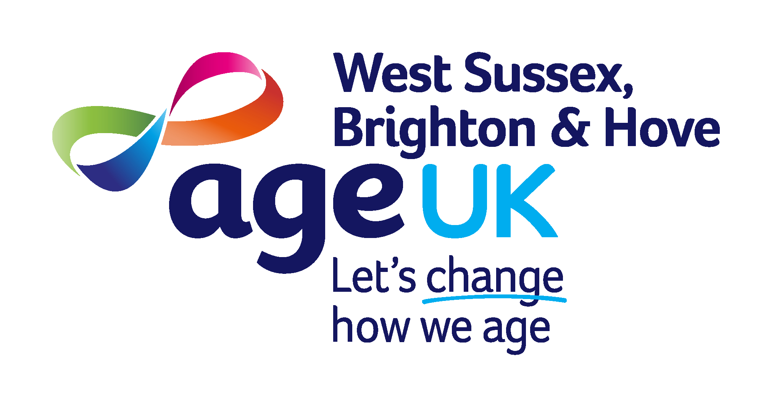
Adur Community Club Timetable

For more details, please call 07563 382953 or email adurcommunityclubs@ageukwestsussex.org.uk to book a place. Please note we are now only able to accept payment by card at our community clubs.
We look forward to welcoming you!

Monday | 10.30 – 12.30 | Monday Social Club* with CBE class | Marsh House, Park Lane, Southwick BN42 4DL
1st Monday of every month | 10.30 - 12.30 | Silver Bullet – Men's monthly meet up | The Royal George, Upper Shoreham Road, Shoreham By Sea, BN43 6TA
Tuesday | 10.30 – 12.30  12.30 - 13.30 | Coffee Morning*  Lunch Club* | Both at - Milward Court Wilmot Road, Shoreham,  BN43 6BU
Wednesday | 10.00 – 12.00  13.00 – 15.00 | ‘Welcome Club’ social group  Bingo Club | Both at - The Shoreham Centre, Room 2  Pond Road, Shoreham, BN43 5WU
* Transport is available at these clubs, please call Dial-a-Ride direct on 01903 530053 to book, additional cost will apply.

