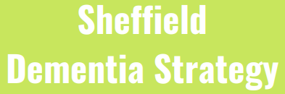

Spring Survey 2021 –
Feedback from people living dementia and their carers/family about what is working well and what else needs to happen

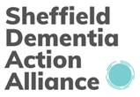

- Context and Introduction

The Sheffield Dementia Strategy (2019-2024) was developed together by people living with dementia, their families, and the organisations working to support them.

The strategy aims to make sure that people living with dementia of all ages and their families are supported to live to their full potential. It includes 13 commitments which describe how we will do this in Sheffield (see appendix 1 of this document for a summary of the commitments or you can read the full strategy here.).

We have continued to progress activity towards the 13 commitments over the last year, and we have regularly reviewed our priorities and activity to ensure that we have been responsive to the impact of the pandemic.

Commitment 13 of the Strategy is that We will monitor the strategy and the implementation plan supporting it and as part of this ensure this that the voices of people living with dementia and caring for those living with dementia are heard and inform the work of the strategy.

The Dementia Strategy Implementation Group (DSIG) (a cross-organisational Group which oversees the strategy) intended to carry out engagement on the progress of the strategy in March 2020. However, this was delayed by the pandemic.

In spring 2021, DSIG decided it was the right time to revisit these plans and we launched a short survey (running across March and April) to help us gain people’s views on what is working well and what else needs to happen.

The organisations working to achieve the strategy are using the feedback from the survey to:
- Help monitor progress and impact of the strategy
- Shape ongoing work towards the 13 commitments
- Influence plans for further engagement, communication, and activity

This report summarises:

- What we asked in our spring 2021 survey
- Headlines of the responses that we received, including key themes and issues
- A brief analysis of what we are already doing, and what more we plan to do, to address key themes and issues identified through the survey

- What the Survey asked
The survey was deliberately kept short and simple, as we wanted to encourage as many people as possible complete it.

The questions within the survey were:

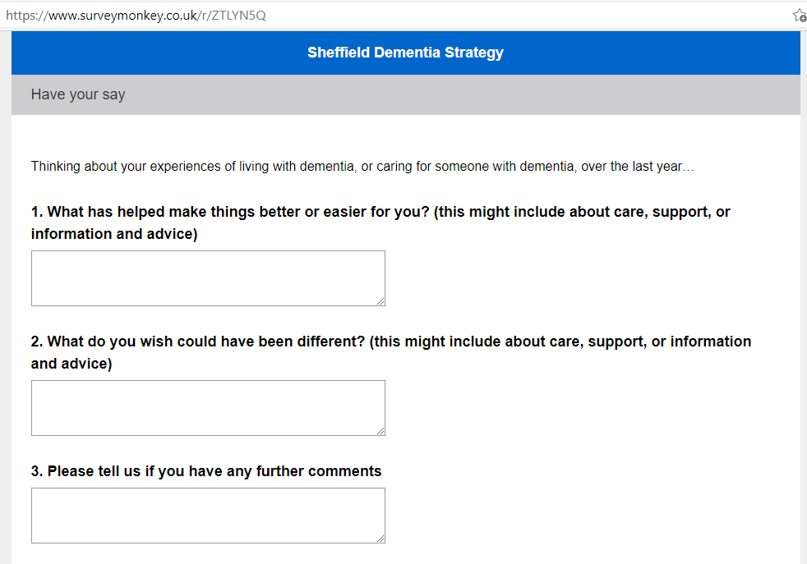

- Who responded to the survey
We promoted the survey widely within the organisations working to achieve the Dementia Strategy, to the community organisations working directly with people living with dementia, and via organisational social media channels. We asked community workers to support people with dementia and their carers who wanted to take part, by asking them the questions and then completing the survey for them. Due to Covid restrictions, we did not focus on using paper versions of the survey.
We had 68 responses in total. Some of these were completed on behalf of carers/people with dementia by community workers and included feedback from several respondents. The majority of respondents were an (unpaid/informal) carer / family member of someone living with dementia.
We had responses from people who were at different stages in their dementia journey, but it was evident from the responses that a lot of the respondents were people supported by (People Keeping Well) community dementia services. This was all very useful feedback, but we acknowledge that as part of our ongoing commitment to engage with people as part of the work of the strategy, we need to continue to find ways to reach out to all groups of people living with dementia and their families/carers.
Please tell us if you are...
Answer Choices | Responses
an individual living with dementia | 7.58% | 5
a carer or family member of someone living with dementia | 78.79% | 52
A member of staff | 9.09% | 6
A member of a community organisation | 10.61% | 7
None of these | 4.55% | 3
 | Answered | 66
 | Skipped | 2

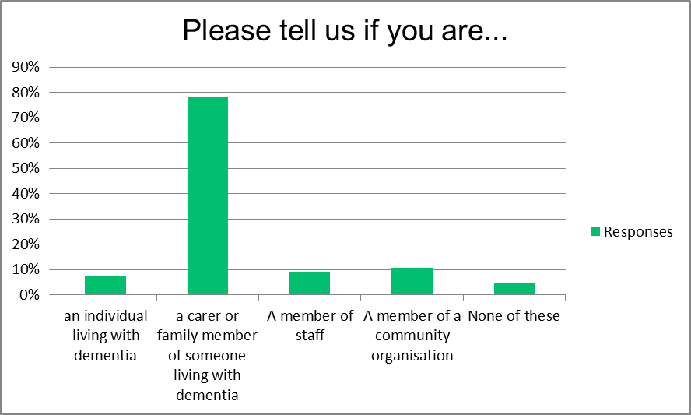
80% of respondents were female and 20% male.

90% of respondents were White British. To note, approx. 81% of the population in Sheffield overall is White British. However, this percentage is much lower for those aged 65 years and older at about 6%. As a large proportion of the survey respondents are family carers of elderly people it can be estimated that many (although not all) are towards the older age range, which means that survey respondents are probably fairly representative of the wider population.

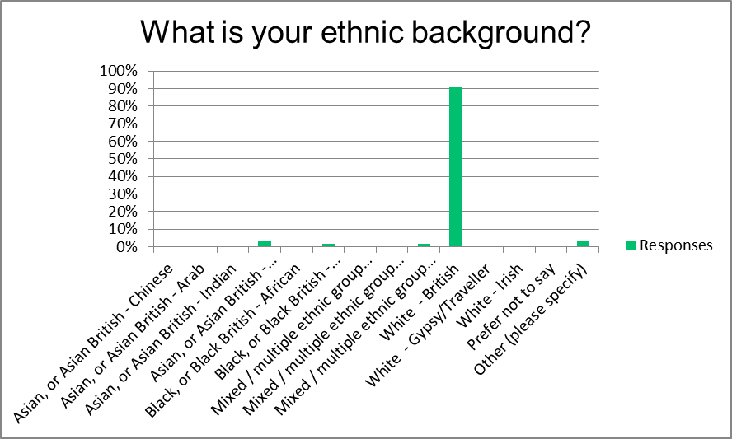
Only one person identified as lesbian and one person as bisexual. Office for National Statistics data in 2018 reported that the proportion of people identifying as lesbian, gay or bisexual (LGB) was 2.2%. Younger people (aged 16 to 24 years) were most likely to identify as LGB in 2018 (4.4%).

Almost half of respondents belonged to a Christian religion and almost a quarter had no religion. 4.6% of respondents were Muslim.

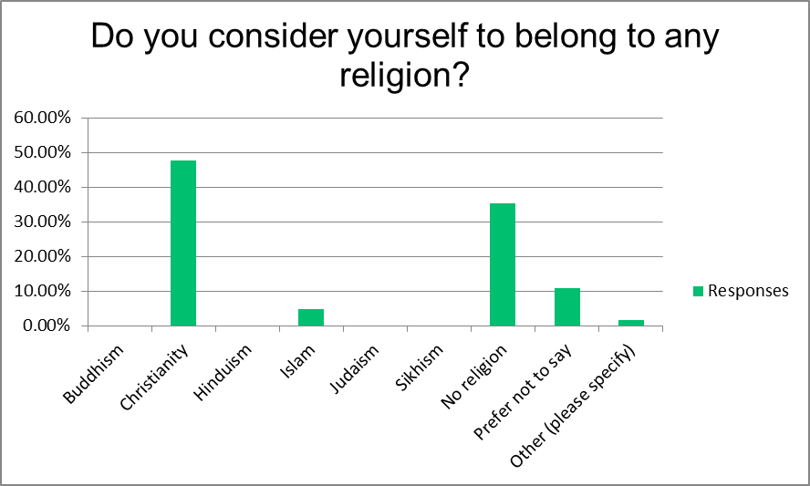
- Summary and headlines of the responses from the survey

  - What people told us about what made things better or easier over the last 12 months – key themes:

- The invaluable difference that support and love from family and friends has made over this difficult time. This is important to celebrate and also to recognise how this links to the themes in the next section about supporting carers. In addition, what was evidenced from many answers was that community dementia provision (for example from People Keeping Well dementia support organisations) had helped people to form peer support networks and make friends with people in similar situations.

Examples of feedback about what has helped:
- “Only family”
- “Love”
- “My friends and family, neighbours and dementia link worker made this hard time easy for us by staying in touch and been a listening ear for us and gave us hope and positivity.”
- “Meeting people in the same boat who understand without having to explain everything.”
- “The group zoom calls have helped. It’s nice to meet up with people, learn more about dementia and hear what others have gone through. The activities have brightened up the day for my mum who is at home with little contact during the current situation. She’s really looked forward to them.”

- Existing services that support people living with dementia are valued and have made a massive difference to people’s lives over the last year

Examples of feedback
- “Information, advice from the memory service”
- “Daily care visits to relieve the pressure on the full-time carer with hygiene tasks, help keep dignity”
- “Support Respite care, Regular Carers.”
- “The amount of support from Adult Social Services and the information available helped with me being able to care for my father with Dementia”
- “Staff from GP onwards were wonderful, very understanding and courteous with my father.”
- “The support of staff at Burton Street has been invaluable.”
- “Support nurse from older adult mental health team. Regular zoom and phone calls from burton street day centre.”
- “Manor Dementia group support zoom meetings.”
- “Memory café: Been receiving a call every week – a listening ear for us… Been referred to the food bank. Regular activity packs which included some treats as well. Each pack was tailored personally to everyone, including cultural and religious needs. When the restrictions were more relaxed, they were able to go for walks with a volunteer, getting out and about”.
- “I felt really cut-off as a carer and felt worse than ever… one of the things that kept me and my wife going is the check in calls from ShipShape dementia worker. And the activity packs which were focused round our needs”
- “The wealth of courses and leaflets and advice [from the community dementia service] that have helped me to make lifestyle changes and decisions to help slow down progression”

  - What people told us about what they wished could have been different over the last year – key themes:

- Time taken to receive a dementia diagnosis (incl. time taken by GPs for their role in this)

Examples of feedback:
- “The diagnosis of Alzheimer's took over three years”
- “Slow referral for assessment for my Mothers dementia. It’s been 2 months now”
- “Wish pursued mental health services who were really slow in arranging my mum’s assessment and she passed away before they did it”
- “Earlier referral, knowledge of devices available to support independence [would have helped make things better]”
- “The advice from our Doctors practise to encourage my wife to "talk to them" was not much help, when my wife says that she perfectly OK...But her family know otherwise.”
- “The initial assessment with the GP was a series of questions which dad manged to get 100% at on two previous occasions some years apart. As a family we knew dad was losing his memory and struggling but the GP was powerless to take further steps because this assessment seemed to show there was no problem”.

- Carers can access, and are offered, support when they need it

Examples of feedback:
- “I don’t know how things could have been different in a pandemic. However, it is impossible to live well with dementia in isolation. The responsibility, isolation and loneliness is crushing.”
- “Much has been made, quite rightly of people in care homes from a national perspective but little about the invisible care given to our elderly relatives cared for at home which has been tough.”
- “Someone to talk to about what to expect”
- “Carers said they really wanted someone to come and support for a bit of time to give the carers some respite”
- “More services for ex carers”

3. Better availability of care and support (including during the pandemic)

Examples of feedback:
- “More easy access to support and care. I am living alone and I'm not a digital person. I wish someone came and do door-step visit. For sure don't want other lockdown. Want to go out and about more.”
- “Day care at Care home remaining open”
- “For the day centre to have remained open, to keep in contact with others, would have felt less isolated”
- “Carers said they really wanted someone … to take some of the clients with dementia out for a walk to give them some time to themselves”
- “More support for my husband to take him out for the walk.”
- “Activities or respite during the pandemic would of been useful to help their quality of life and ease the pressures on the carer”
- “More daycentres for dementia people”
- “More daycentres for African/Caribbean dementia people in Sheffield- there is nothing for this culture”

4. People need easy access to the right information and advice, at the right time

Examples of feedback:
- “It was hard to know where to go for help and advice at the beginning. Had long periods of time waiting to be contacted and kept in the loop especially when the person was getting assessed and state worsening quickly.”
- “I desperately needed and still need someone with knowledge about dementia and associated mental health issues to talk to instead of having to use websites”
- “Who to go to in a crisis?”
- “It is a shame there is not a central well known service offering information and advice in the way that the Alzheimer’s society used to”
- “More information and advice initially, a booklet and “ring if you need help “wasn’t enough when you are struggling with a diagnosis and worrying about the future. I have got most of my information from Facebook carer groups.”

- Analysis of what we are already doing, and what more we plan to do, to address key issues identified through the survey

Key themes from the survey | Dementia Strategy Commitment/s this links to | What have we been doing already on this theme | Do we need to do anything else? If we do, what else?
- Time taken to receive a dementia diagnosis | Commitment 3 – We will improve access to the diagnosis of the diseases that cause dementia at the earliest possible stage for the people of Sheffield. | Primary Care and Acute dementia referral and diagnosis pathway now updated and reflects improved working between primary and secondary care services: includes access to memory service; guidance on ‘pragmatic diagnosis’ and diagnosis in care homes. This means that clear and consistent information has been made available to GPs and STH.  Alzheimer's Society Dementia Short Term Intervention Service (available to GP and social workers) is now well established – includes supporting undiagnosed people presenting in/near crisis.  Diagnosis Dementia training session held for health and social care staff, with good attendance. Recording of session being promoted widely. | Local performance is better than the national and regional average for diagnosis rates/prevalence – however this has fallen over the last year (this is a national trend). Linked to this, referrals from Memory Service to Dementia Advice Sheffield (DAS) have been limited in 2020.  We need to explore what more we can do locally to improve diagnosis rates, get DAS referrals from the Memory Service back up to previous levels, and to further support GPs to make (appropriate) ‘pragmatic’ diagnosis. We need to understand how quickly GPs make referrals to the Memory Service when someone presents with suspected dementia and if there are any barriers to this.  There is some non-recurrent dementia diagnosis (including pre and post diagnosis) funding from NHSE for Sheffield from June 2021 (until March 2022).  One issue that came up in the survey that we have not yet explored in detail was where there was conflict because the person with (suspected) dementia tells GP they do not have memory loss meaning diagnosis/support is not pursued; but the family feels they do.
- Carers can access, and are offered, support when they need it | Commitment 5 - We will provide high quality support to families and carers of people with dementia in Sheffield to help people with dementia maintain their independence for as long as possible. | Last year, the Carers Centre and Sheffield Age UK led the Dementia Covid project, which used GP dementia registers to contact families and offer them support, for example through accessing the community dementia provision and the carers centre.  We have raised awareness about how carers can access support during Sheffield Dementia Month (May 2021) | There is ongoing work to raise awareness about the need to support carers and increase referrals from health and social care teams to the carers centre.  We are producing on a short video to raise awareness with carers about the support that they can access.  A number of people talked about needing more support as carers, and respite from their caring responsibilities – we need to understand if this ‘gap’ was due to people not being linked into carers services/adult social care, or if they were linked in but they didn’t feel that what they were offered met their needs. If the latter is the case, is this primarily due to pandemic restrictions or a more ongoing issue?
- Better availability of care and support (including during the pandemic) | Commitment 10 - Care and support services will take account of the needs of people with dementia. | There has been an ongoing focus within the work of the Strategy on training and supporting staff to ensure that the services they provide take account of the needs of people with dementia – for example through DAS and the dementia ‘learning lunches’. However during the pandemic many care and support services have unavoidably been closed and this has been very challenging for families. Some services have been adapted or been able to offer restricted services and the resulting positive outcomes have been reflected in the ‘what helped’ feedback from the survey. Commissioners have shared good practice across providers to promote innovative ways of working. | We will ensure that this feedback is shared with health and social care commissioners, and providers, to inform service provision and commissioning plans.  We need to understand if this ‘gap’ was due to people not being linked into services, or if they were linked in but they didn’t feel that what they were offered met their needs. If the latter is the case, is this primarily due to pandemic restrictions or a more ongoing issue?
- People need easy access to the right information and advice, at the right time | Commitment 4 - For people with dementia, support in Sheffield will be more personalised, local and accessible to help people to remain independent for as long as possible. | Information and advice are offered by Sheffield Memory Service and STH Neurology, including referral via DAS to the Community providers and Sheffield Memory Service’s help-line for anyone who has been referred to the service.  Dementia Advice Sheffield is available to support, advise and train providers / organisations that help people to maintain independence.  In 2019/20 DSIG carried out a review of the information and advice that was available in Sheffield and made improvements to where this information was located and maintained. Sheffield Dementia Month (May 2021) has continued and refreshed this work.  DSIG is currently looking at ways to improve what information and advice is available to people when they are experiencing, or at risk of experiencing, a crisis situation.  Sheffield Teaching Hospitals have been working to improve information that they provide to people with dementia on discharge from hospital about community dementia support. | We will ensure that this feedback is shared with health and social care commissioners, and providers, to inform service provision and commissioning plans. For example, there is currently no citywide commissioned service to offer advice to people living with dementia/their carers and signpost people to their local community dementia support.  We will continue to improve the information and advice available to people when they are experiencing, or at risk of experiencing, a crisis situation.  Sheffield Teaching Hospitals will continue to improve the information that they provide to people with dementia on discharge from hospital about community dementia support.  We will revisit the DSIG review of the information and advice that is available and identify next steps.
- Responding to the positive feedback from the survey:  - Existing services that support people living with dementia are valued and have made a massive difference to people’s lives over the last year  - This has included the positive impact of work to help people to form peer support groups | Commitment 4 - For people with dementia, support in Sheffield will be more personalised, local and accessible to help people to remain independent for as long as possible.  Commitment 5 - We will provide high quality support to families and carers of people with dementia in Sheffield to help people with dementia maintain their independence for as long as possible. | Community services were as also promoted to GPs/STH in the updated diagnosis protocol. Referral to community support accelerated via through the Community Dementia (Covid) project.  Dementia Advice Sheffield is available to support provider/organisations that help people to maintain independence.  Dementia learning lunches have promoted existing services and support to staff so they can access training/advice, and support clients to access services. | We will ensure that these positive comments are shared with health and social care commissioners, to inform their future and ongoing plans for dementia commissioning in Sheffield.

Appendix 1 – Summary of the 13 Commitments in the Strategy

