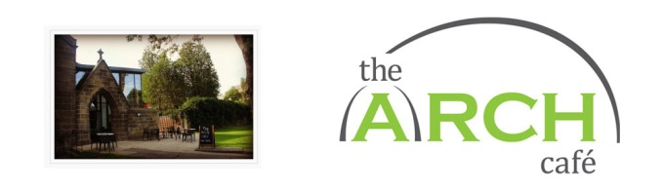
CHRISTMAS MENU 2019

Two courses £16.95 // Three courses £18.95

*Available from 2nd December – booking is essential*

Call 0113 389 3002 to book or come and visit us in the café!

We can cater for all dietary requirements, please specify these when booking.

For parties of 5 or more we require a £5.00 deposit per head to be paid up to 2 weeks before your booking.

We do not add a service charge to your bill; however, we happily accept donations. All donations and profits from the café go toward funding the services of Age UK Leeds.

STARTERS

Seasonal, homemade soup of the day. Served with granary bread and butter
Homemade chicken liver pâté with ciabatta toast and Yorkshire onion chutney
Avocado and bacon salad
Avocado and feta salad

MAIN COURSES

Roast Turkey and stuffing
Mushroom, Cranberry and Brie Wellington
(Both served with rosemary roast potatoes and seasonal vegetables)
Vegan option available on request

DESSERTS

Lemon Cheesecake
Mincemeat tart with a crumble topping
Roasted plums with Amaretto
(All served with a choice of cream or ice cream)

