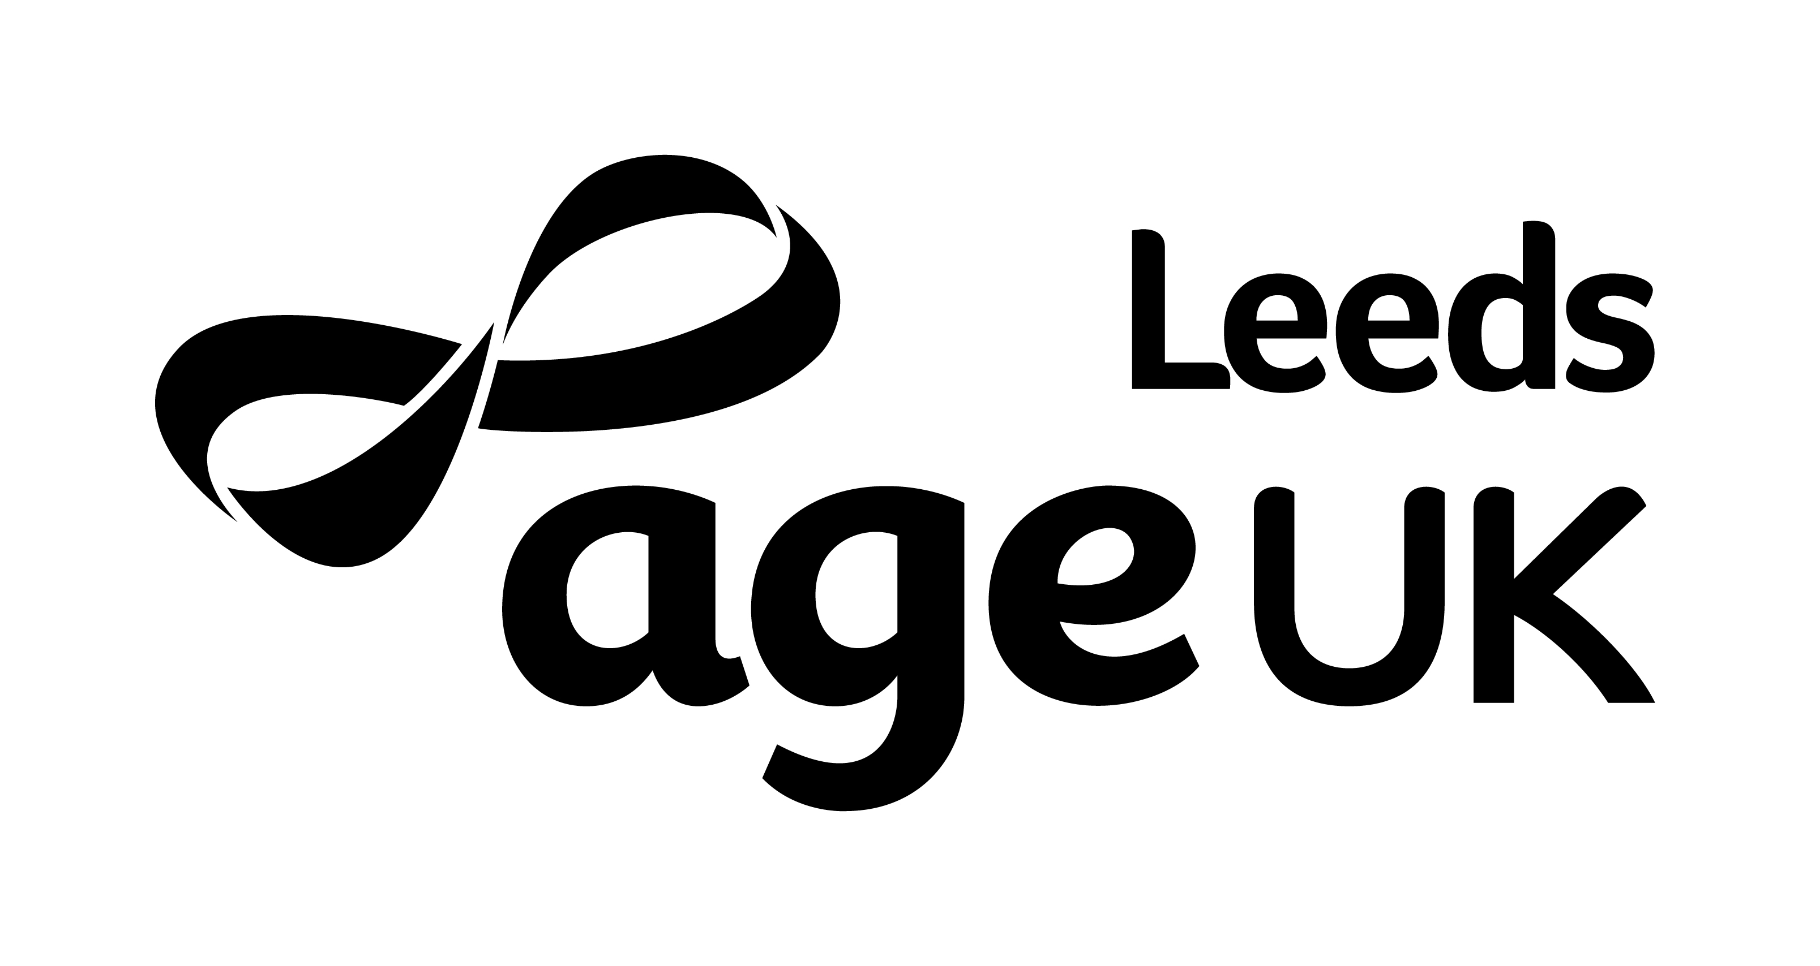
Equal Opportunity Monitoring Form

The Equal Opportunity Policy of Age UK Leeds states we will not unjustifiably discriminate against individuals on the grounds of age, disability, gender reassignment, marriage and civil partnership, pregnancy and maternity, race (including colour, nationality and ethnic origin), religion or belief, gender, and sexual orientation. In order that we can measure the impact of this policy please tick the appropriate boxes. This information will be used for AUKL monitoring purposes only and will be kept separate from any other personal details.

Gender
I identify my gender as: Male Female Prefer not to use my own term

If you prefer to use your own term please provide this here:
Is your gender identity the same as was assigned at birth?: Yes No Prefer not to say
Age
16-24 25-34 35-44 45-54 55-64 65-74 75-84 85-94 95 and over
Race
White – British  White – Irish  White – other background  (please state)…………………  Indian  Pakistani  Bangladeshi  Chinese  Any other Asian background  (please state)…………………  Arab/Middle Eastern  Any other background (please state)……………… |  |  | White & Black Caribbean  White & Black African  White & Asian  Any other mixed background (please state)……………………....  Black Caribbean  Black African  Any other Black background  (please state)…………………...  Prefer not to say
Religion or belief  Buddhist  Hindu  Christian  Jewish |  | Muslim  Sikh  Any other religion or belief  None  Prefer not to say
Disability
Do you consider yourself to be a person with a disability? Yes No
This includes people with long term health conditions.

Sexual Orientation
Heterosexual/straight Bisexual Gay man Gay woman/Lesbian
Prefer to use my own term
If you prefer to use your own term please provide this here:

