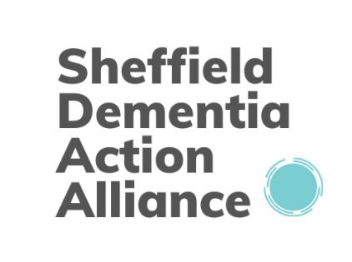

Dementia Friendly Environment Checklist
Where possible your business premises should be as dementia friendly and inclusive as possible. Below is a checklist. This list is not exhaustive. Don’t be put off if you cannot tick them all – work in progress! If possible, speak to people living with dementia and ask them how they find your premises.
Quiet space
o Do you have a quiet space for someone who might be feeling anxious or confused? A few minutes with a supportive person might be all that’s needed.
Signage
o Are signs clear, in bold face with good contrast between text and background?
o Is there a contrast between the sign and the surface it is mounted on? This will allow the person to recognise it as a sign.
o Are the signs fixed to the doors they refer to? They should not be on adjacent surfaces if at all possible.
o Are signs at eye level and well-lit?
o Are signs clear images or icons?
o Are signs placed at key decision points for someone who is at the building/area for the first time?
o Are signs for toilets and exits clear? These are particularly important.
o Are glass doors clearly marked?
Lighting
o Are entrances well-lit and make as much use of natural light as possible? Avoid using areas with bright light or deep shadows

Flooring
o Are floors matt in colour without reflections and deep shadows? Reflections can cause confusion.
o Are carpets plain in colour without bold patterns? Plain surfaces are easier; patterns can cause problems to people with perceptual problems.
o Are changes in floor finish flush rather than stepped? Changes in floor surfaces can cause some confusion due to perceptual problems. If there is a step at the same time you also introduce a trip hazard.
Changing rooms and toilets
o Do you have a changing room (where applicable) where an opposite sex carer or partner can help out if the person needs help with their clothes?
o Do you have a unisex toilet or other facility which would allow someone to have assistance without causing them or other users embarrassment?
o Are toilet seats a contrasting colour to the walls
o Are the rest of the toilets colour contrasting?
Seating
o Do you have a seating area where people are waiting? This can be a big help.
o Does your seating look like seating? People with dementia will find this easier (for example a wooden bench would be preferable to an abstract metal Z-shaped bench).
Navigation
o Do you have landmarks around the building to help people navigate? Research shows that people with dementia use “landmarks” to navigate their way around, both inside and outside. The more attractive and interesting the landmark (which could be a painting, or a plant) the easier it is to use it as a landmark.

Score _____/20

You should be aiming for as high score as possible to ensure your environment is dementia friendly.

This is just the start of making your environment dementia friendly for the next steps contact us at sdaa@ageuksheffield.org.uk.
Sheffield Dementia Action Alliance acknowledges the Alzheimers Society for the Dementia Friendly Environment Checklist which we have adapted.

