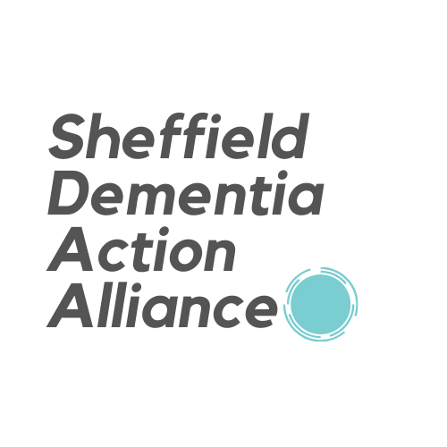

Sample Members’ Action Plan: Pledges
By joining the Sheffield Dementia Action Alliance, your organisation will be joining a network of community, faith, business, voluntary, charity and statutory organisations committed to raising awareness and reducing the stigma associated with dementia.

Please try to commit to a small number of pledges/actions for your organisation to develop dementia friendly services, and tell us what you’re doing. We can then support you to achieve these goals and review them annually to support you on your journey of becoming a dementia friendly organisation and an ally for everyone affected by dementia.

Suggested action areas | Your actions/pledges | When are you aiming to do this?
Dementia-friendly services  How can you make it better for your customers who have dementia to use your services? | We will encourage and support the staff and volunteers who provide activities, support events, deliver presentations and workshops to attend the dementia starts training sessions, bronze , silver and gold! This will mean that staff and volunteers will feel confident in providing all that we offer to people living with dementia and their carers and that we can be as inclusive as possible.
Dementia-friendly spaces  How can you adapt your building to be more dementia-friendly? | Use the environmental checklist to work out how dementia friendly our premises are, then create a plan of action to make improvements to the areas that do not meet the criteria. This will be an ongoing continuous piece of work to improve our premises and ensure they are as accessible and inclusive as possible. When we have made improvements we will involve and encourage our clients and colleagues who are living with dementia or carer, family members or friends of someone living with dementia to help us review the progress we have made and highlight any further improvements we could make. When we are happy with the changes we have made we will share before and after and progress photos as well as hints and tips and things we learned along the way with our sister organisations and with the SDAA so that our learning can be shared more widely across the alliance.
Dementia-friendly workplaces  How can you support staff who may be experiencing memory loss, or caring for someone who has dementia? | We will run creative workshops and explore issues around dementia to create engaging conversation and raise awareness, tackle misconceptions and generally open a wider conversation about a fairly stigmatised issue. We want to increase awareness and knowledge of dementia, both among our staff and our wider community as a whole.

Once completed, please send your form to: sdaa@ageuksheffield.org.uk

