By joining the Sheffield Dementia Action Alliance, your organisation will be joining a network of community, faith, business, voluntary, charity and statutory organisations committed to raising awareness and reducing the stigma associated with dementia.

Please try to commit to a small number of pledges/actions for your organisation to develop dementia friendly services, and tell us what you’re doing. We can then support you to achieve these goals and review them annually to support you on your journey of becoming a dementia friendly organisation and an ally for everyone affected by dementia.

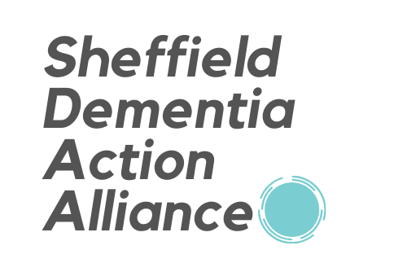
Members’ Action Plan: Pledges

Membership/Organisation name | Conact name | Contact email address | Date form completed

Suggested action areas | Your actions/pledges | When are you aiming to do this?
Dementia-friendly services
How can you make it better for your customers who have dementia to use your services?
Dementia-friendly spaces
How can you adapt your building to be more dementia-friendly?
Dementia-friendly workplaces
How can you support staff who may be experiencing memory loss, or caring for someone who has dementia?

Once completed, please send your form to: sdaa@ageuksheffield.org.uk

