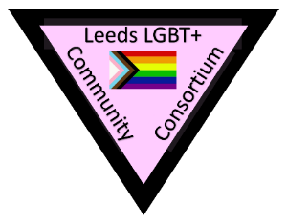
Leeds LGBT+ Community Consortium
Cool Co-ordinator Application Form

Name:
Pronouns:
Email Address:
Mobile Number:

Please look at the attached job description and specification then complete the following sections.

- What previous experience have you of planning, co-ordinating and delivering projects? (Please provide as much detail as possible.)
- Please outline any experience in:
  - Using social media platforms
  - Improving digital literacy
  - Using any other relevant software

- Please outline your understanding of the experiences and needs of LGBT+ communities, older or disabled people.

- Please provide the name and email address of a referee (can be known in either a personal or professional capacity).

Name:
Email:
Relationship to you:

Please return this application form by email to LGBTQCC@gmail.com by end of Sunday 13th December 2020. Interviews will take place via Zoom at the end of that week with a view to commencing the work in early January 2021

