Walking more can help:
- Prevent illnesses like heart disease, diabetes and high blood pressure
- Improve mobility and flexibility
- Give you that feel good factor, reduce stress and improve your sleep
- Keep yourself at a healthy weight

For more information please contact:
Rachel McHale
Age UK Leeds
The Bradbury Building, Mark Lane
Leeds, LS2 8JA
Tel: 0113 3893007
Mob: 07432 477529
Email: rachel.mchale@ageukleeds.org.uk

Or visit the Age UK website: www.ageuk.org.uk/leeds

For more information on Walking for Health visit: www.walkingforhealth.org.uk
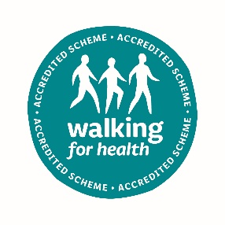
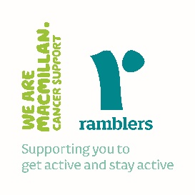

Age UK Leeds is a registered charity and company limited by guarantee, (registered charity number 504899, registered company number 1236909) Registered office: Bradbury Building, Mark Lane, Leeds, LS2 8JA
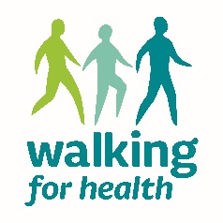

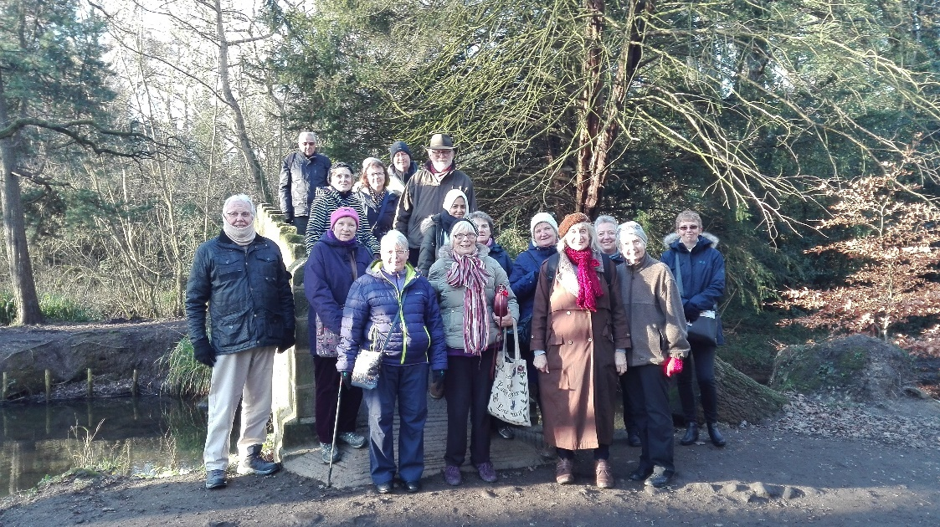
Walking for Health

The Age UK Leeds Walking for Health group is open to anyone who is over 50 and living in Leeds. Our health walks take place every Tuesday morning.

We offer a variety of routes of 60 to 90 minutes in length, and all walks include stops along the way.

Walks are FREE and there is no need to book, all are led by friendly, trained volunteer walk leaders as part of the national Walking for Health programme.

See overleaf for the May - July 2019 programme of walks.

7th May | University Buildings
14th May | Golden Acre/Adel Dam*
21st May | Armley Canal Road to town*
28th May | Central Riverside
4th June | Wykebeck Valley 2*
11th June | Squares 2
18th June | Wykebeck Valley 3 *
25th June | Waterfront West
2nd July | More Squares
9th July | Kirkstall Goit/waterside*
16th July | University Arts Trail
23rd July | Gledhow Valley woods *
30th July | Richmond Hill

*These walks will involve a bus journey so please bring your bus pass/bus fare. The walk will be of a similar length to usual but due to the extra journey time we aim to be back in central Leeds by 1pm.

Before you start walking…

If you haven’t been very active before, always build up gradually and speak to your GP before increasing your activity levels.

Please wear appropriate foot wear with flat soles which you will be comfortable walking in and clothing suited to the weather conditions. You are advised to bring a bottle of water or soft drink, especially in hot weather.

If you are attending a walk for the first time please turn up at the meet point 10 minutes before the start time and introduce yourself to the Walk Leader. There will be a registration form to complete.

All walks start from The Arch Cafe on Mark Lane every Tuesday at 10.30am and aim to be back at The Arch Café for 12 noon.

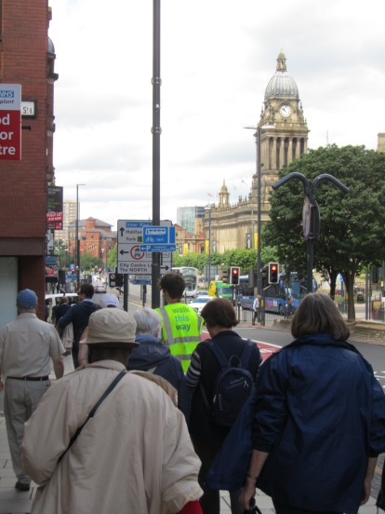
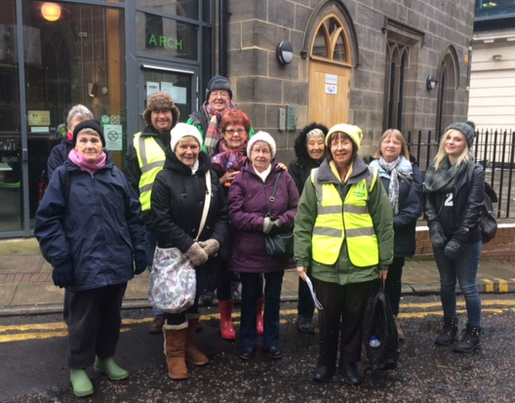

More active, more often…

Any amount of activity that is appropriate for your age group and health makes a difference. It is recommended that we build up to doing 150 minutes of moderate physical activity a week. A good way to achieve this is to try and do at least 30 minutes activity on at least 5 days of the week. Moderate activities include anything that makes you breathe more heavily and feel slightly warmer than normal.

Walking is an ideal way to take regular exercise, it is sociable and enjoyable and enables you to get out in the fresh air and see places you may not usually visit.

Joining Age UK Leeds’ Walking for Health group is a great way to get more active, more often!

