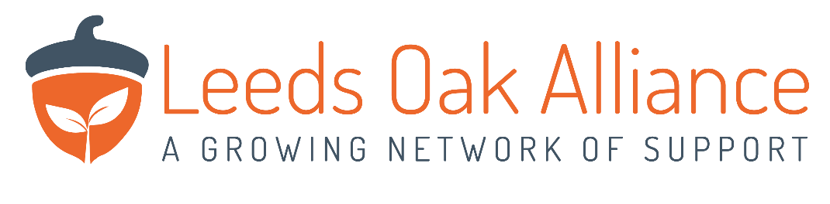
Leeds Oak Alliance Coronavirus Position Statement

Our 3rd sector Hub at Bexley Wing of St James’s Hospital will be suspended until further notice while we adopt measures to help prevent the spread of the Coronavirus (COVID-19).

The decision to close has been taken in light of the latest government guidance to limit social contact to minimise the risk of contamination and also to free up our staff teams to deal with urgent matters within our own organisations.

The current priorities of all Leeds Oak Alliance partner organisations are to keep the vulnerable people/carers we work with safe and well and to maintain contact with them wherever possible.

We are currently drawing up plans to maintain support to people in Leeds and will focus our efforts on those most affected.

