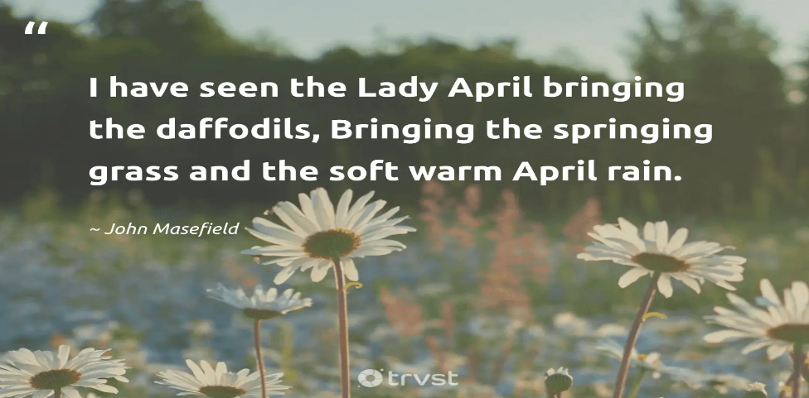
Day Opportunities Daily Planner

Date 20/04/2026
Time | Activity
10:00 – 11:00 | Coffee, Tea, Morning
11.00 – 12:00 | Group 1  Spring gardening | Group 2  Making a St. George bunting
12:00-12:30 | Group 1  Cognitive stimulation | Group 2  Seated Yoga
12:30-13:30 | Lunch
13:30-14:30 | Group 1  Memory tray game | Group 2  Playing ring toss
14:30- 15:00 | Enjoy the music

