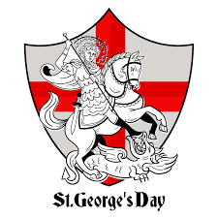
Day Opportunities Daily Planner

St. George’s Week
Date 22/04/2026
Time | Activity
10:00 – 11:00 | Coffee, Tea, Morning & Newspaper
11:00 – 12:00 | Group 1  Yoga with Sue | Group 2  Discussion about St. George
12:00-12:30 | Group 1  General Knowledge Quiz | Group 2  Early Lunch (RAF)
12:30-13:30 | Lunch
13:30-14:30 | Group 1  Art & Craft  Stencil art | Group 2  Tour to the RAF Museum
14:30- 15:00 | Year 50s & 60s Songs

