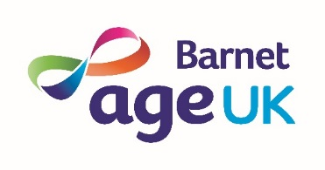
Tuesday and Thursday Clubs
August 2019

Age UK Barnet, Ann Owens Centre, Oak Lane, East Finchley, London, N2 8LT Tel: 020 8432 1415

 | 10 – 11 | 11 – 12 | 12.30 – 1.30 | 1.30 – 3pm
Thursday 1st | Tea & Chat | Gentle Exercise | Lunch Club | Hoy
Tuesday 6th | Tea & Chat | Gentle Exercise | Lunch Club | Bingo
Thursday 8th | Tea & Chat | Gentle Exercise | Lunch Club | Musical Afternoon: Glenwood Jazz Group - back by popular demand
Tuesday 13th | Tea & Chat | Gentle Exercise | Lunch Club | RahRah Theatre: Country Roads Take Me Home
Thursday 15th | Tea & Chat | Gentle Exercise | Lunch Club | National Citizens Service students’ meeting 2pm
Tuesday 20th | Tea & Chat | Gentle Exercise | Lunch Club | Singalong with Howard
Thursday 22nd | Tea & Chat | Gentle Exercise | Lunch Club | Bingo
Tuesday 27th | Tea & Chat | Gentle Exercise | Lunch Club | NCS students special event, 12 x 16 & 17 year olds
Thursday 29th | Tea & Chat | Gentle Exercise | Lunch Club | Games

All activities may be subject to change.

