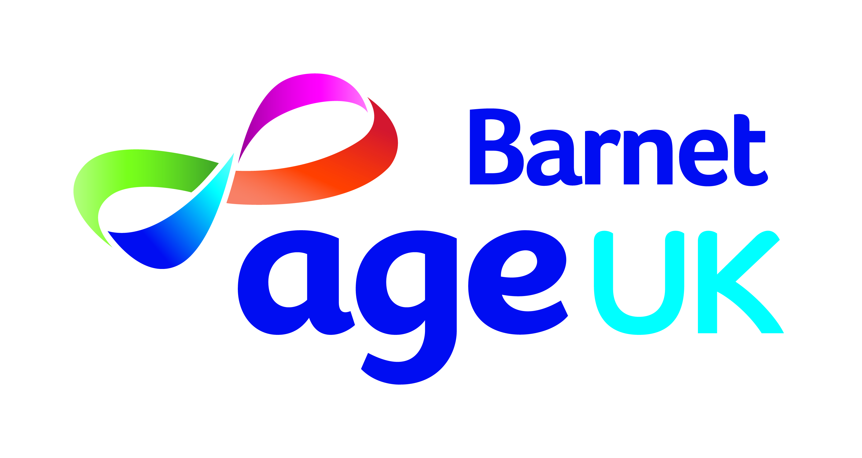
Trustee application form

Thank you for your interest in becoming one of our Trustees
Age UK Barnet is an incorporated charity, first established over 40 years ago. The charity serves and promotes the interests of all older citizens of the London Borough of Barnet, from all walks of life and ethnic communities.
What do Our Trustees do?
The Board of Trustees has 12 essential responsibilities:
Set and maintain vision, mission and values |  |  | Ensure compliance with the governing document
Develop strategy |  |  | Respect the role of staff/volunteers
Establish and monitor policies |  |  | Maintain effective Board performance
Maintain proper fiscal oversight |  |  | Promote the organisation
Ensure accountability |  |  | Set up employment procedures
Ensure compliance with the law |  |  | Select and support the chief officer
As a prospective trustee, you will be asked to sign a declaration of eligibility to ensure that you meet the legal requirements to act as a trustee. The following is a brief summary of the key elements of that declaration, in which you will be asked to confirm that you are not disqualified from acting as a charity trustee and that you:
are capable of managing your own affairs |  |  | are not disqualified to be a company director
have no unspent conviction for deception or dishonesty |  |  | have not been removed from office as a trustee
are not an undischarged bankrupt
Please return your completed form by email or post to :
Lisa.robbins@ageukbarnet.org.uk
Age UK Barnet, Ann Owens Centre, Oak Lane, East Finchley, N2 8LT
For general information on Age UK Barnet or if you have specific question about the role of an Age UK Barnet Trustee, please call
020 8203 5040
Personal details
Title |  | First name |  | Last name
Address, including Postcode
Telephone number
Mobile number
E-Mail address
Preferred form of contact
Best time to contact you
References
Please provide details of two people who can support your application.
We will let you know before we contact them.
1 | Title | First name |  | Last name
Address, including postcode
Telephone number
Mobile number
E-Mail address
Relationship to you
2 | Title | First name |  | Last name
Address including postcode
Telephone number
Mobile number
E-Mail address
Relationship to you
An effective board needs to draw on a wide range of experience and knowledge.
We appreciate that not all members will have all elements. Please provide brief, relevant and specific examples for each of the following areas, including appropriate dates. We are particularly interested in how you have applied the following skills:
Team working |  | Problem-solving |  | Asking difficult questions
Decision-making |  | Negotiation skills |  | Listening skills
Understanding the needs of older people
Leadership and management
Target setting and performance management

Business and commercial
Finance and investment
Commissioning and fundraising

Marketing
Understanding the needs of diverse communities
Legal and property
Press and public relations, including campaigning and advocacy
Any other information you think may be helpful.

