ZOOM

How to Zoom Using a Computer

- To determine if your computer has a camera: If you can watch videos on the device, then you have sound and camera. If you don’t know, click on the link below to watch a “How to Zoom” YouTube video:
https://www.youtube.com/watch?v=9isp3qPeQ0E
- You may join the meeting up to 15 minutes before the Zoom meeting start time.

Here is an overview of the steps:
- You will receive an email with an “Invitation to join a Zoom meeting”. This invitation contains details re: date & time of the Zoom meeting.
- You log into Zoom to join the meeting. You can see and hear the other participants in the meeting. You are now in the meeting.
- When the meeting has ended or you are ready to leave the meeting, you click “Leave meeting”.

See the following pages for step-by-step instructions.

Step-by-step instructions:
- The invitation.
Below is a picture of a typical Zoom meeting invitation you will receive via email:
_____________________ is inviting you to a scheduled Zoom meeting.

Topic: Book Club Meeting
Time: Apr 15, 2020 02:00 PM Eastern Time (US and Canada)

Join Zoom Meeting
https://zoom.us/j/340629631

Meeting ID: 340 629 631
One tap mobile
+19292056099,,340629631# US (New York)
+13126266799,,340629631# US (Chicago)

Dial by your location
+1 929 205 6099 US (New York)
+1 312 626 6799 US (Chicago)
+1 301 715 8592 US
+1 346 248 7799 US (Houston)
+1 669 900 6833 US (San Jose)
+1 253 215 8782 US
Meeting ID: 340 629 631
Find your local number: https://zoom.us/u/atK4OUcR7

- Open a new web browser window or tab.
  - Highlight, copy and paste the meeting link into the search bar up to 15 minutes before the scheduled meeting start time.
  - Press Enter or Return on your keyboard.
- The link will take you directly to the Zoom meeting. (You do not have to create your own Zoom account.)
  - Click “Join meeting.” The first time you do this you may be instructed to download the Zoom application on your computer. (Follow the prompts given to you by your computer to install the software.)

- In the meeting
- Turn on your computer’s audio and video.
  - You can control your sound and video using icons on the tool bar at the bottom of your screen.
  - The icon for sound is the microphone; the video icon is a camera. Clicking on the icon will turn your sound or video off and on. If there is a red line through the icon, then it is off.

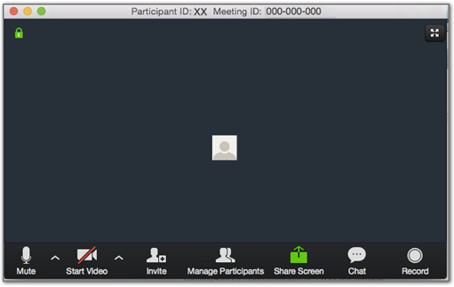

Microphone Video

- How to change your view of the meeting:
The default setting for Zoom is called “Active Speaker View”. The person speaking has the biggest photo.

Click here to change to “Gallery View”

This is “Active Speaker View”
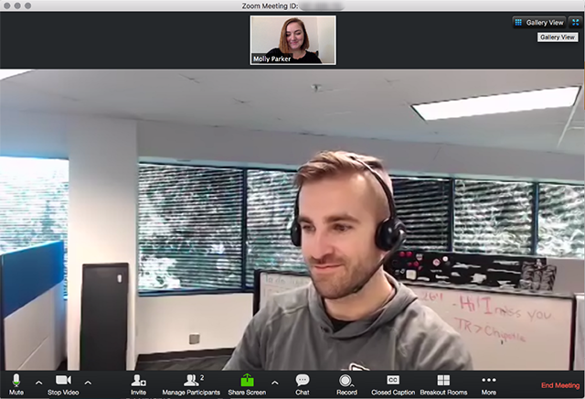
This is “Gallery View”
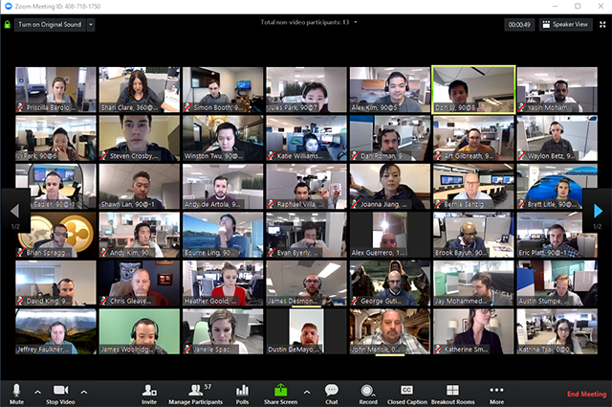
- How to leave Zoom at the end of the meeting:
Look at the toolbar at the bottom of your screen. If you do not see this toolbar, take your mouse and “hover” over the bottom black area of your Zoom window.
  - Click on “Leave Meeting”

Congratulations! You have just completed your first Zoom meeting!
How to Zoom Using an iPad

- Click on the link below to watch a “How to Zoom” YouTube video:
https://www.youtube.com/watch?v=9isp3qPeQ0E
  - This video is using a computer to Zoom. The instructions below highlight some of the unique features of Zooming using an iPad.
- You may join the meeting up to 15 minutes before the Zoom meeting start time.
- You must have the Zoom App installed on your iPad. If you do not already have the Zoom App:
  - Go to the “App store”. Download and install the Zoom app.

Here is an overview of the steps:
- You will receive an email with an “Invitation to join a Zoom meeting”. This invitation contains details re: date & time of the Zoom meeting.
- You log into Zoom to join the meeting. You can see and hear the other participants in the meeting. You are now in the meeting.
- When the meeting has ended or you are ready to leave the meeting, you click “Leave meeting”.

See the following pages for step-by-step instructions.

Step-by-step instructions:

- The invitation
Below is a picture of a typical Zoom meeting invitation you will receive via email:

___________________ is inviting you to a scheduled Zoom meeting.

Topic: Book Club Meeting
Time: Apr 15, 2020 02:00 PM Eastern Time (US and Canada)

Join Zoom Meeting
https://zoom.us/j/340629631

Meeting ID: 340 629 631
One tap mobile
+19292056099,,340629631# US (New York)
+13126266799,,340629631# US (Chicago)

Dial by your location
+1 929 205 6099 US (New York)
+1 312 626 6799 US (Chicago)
+1 301 715 8592 US
+1 346 248 7799 US (Houston)
+1 669 900 6833 US (San Jose)
+1 253 215 8782 US
Meeting ID: 340 629 631
Find your local number: https://zoom.us/u/atK4OUcR7

- Tap on the meeting link.
  - The link will automatically open your Zoom app and take you directly to the Zoom meeting.

- Joining a meeting:
- If you arrive at the Zoom meeting before the host has started the meeting you will see one or both of the following messages:

- Once the host has opened the Zoom meeting, tap on “Join with Video”
(You may be prompted to allow Zoom to use your iPad’s camera. If so, the answer is “YES”).

- Tap “Call using Internet Audio”
so others at the Zoom meeting
can hear you speak.

You should now be in the Zoom meeting.
- In the meeting
At the top of your iPad screen is a “toolbar”.
- To display the toolbar, tap anywhere in the center of your iPad.
- To see all the Zoom participants simultaneously, tap “Switch to Gallery View”
- The icon for sound is a microphone; the video icon is a camera. Clicking on the icon will turn your sound or video off and on. If there is a red line through the icon, then it is off.

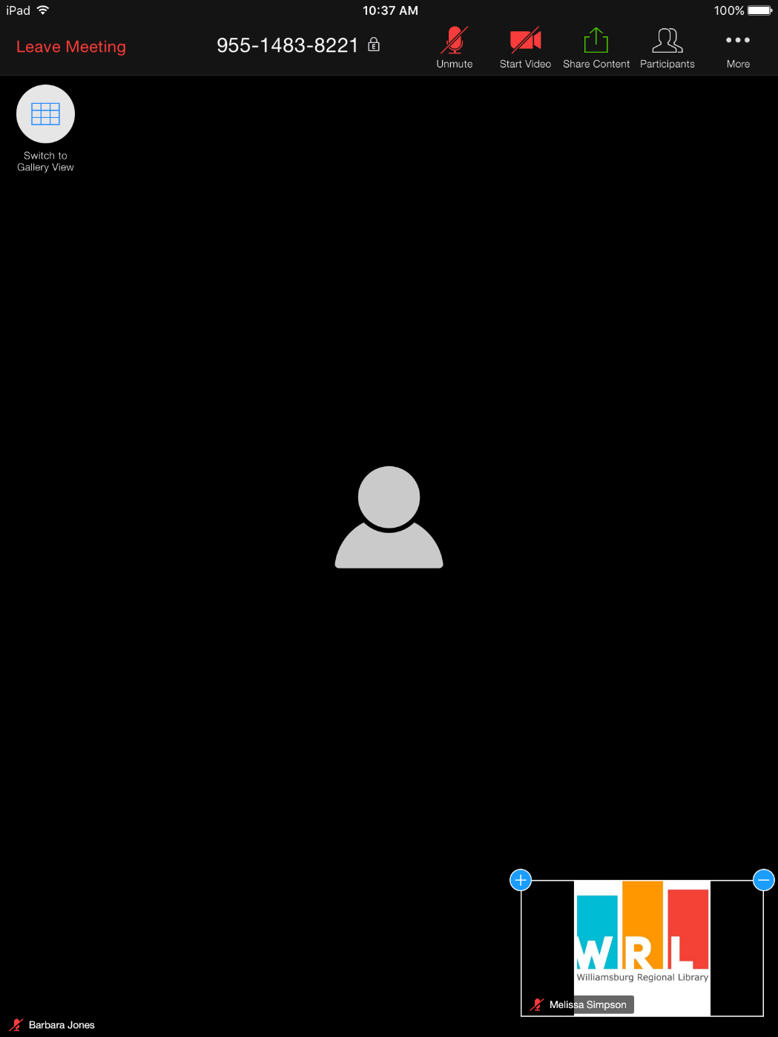
- How to leave Zoom at the end of the meeting:
- Look at the toolbar at the top of your screen.
  - Click on “Leave Meeting”

Congratulations! You have just completed your first Zoom meeting!

These videos might also be useful for beginners wanting to use Zoom on a laptop/desktop - 10mins
https://www.youtube.com/watch?v=9w3Y_9FLgc4

Super straight forward step by step Zoom introduction on a laptop/desktop– 12mins
https://www.youtube.com/watch?v=QOUwumKCW7M

Fun tips and tricks to try with Whatsapp

1. Record hands-free voice notes
While voice notes are one of the most popular features on WhatsApp, many users are unaware that you can record voice notes hands-free.
WhatsApp said: "Did you know that if you hold down the microphone icon and swipe up, it locks the voice note function to 'record', leaving you able to record your message hands-free?
"Once you have finished recording your message, just press send."

2. Bookmark your main messages
While WhatsApp does have a search function, trying to find messages from a while ago can be tricky.
Thankfully, there’s a sneaky way to bookmark key messages to make sure you can find them easily and quickly in the future.
WhatsApp said: "Make use of the 'star' message function where you can bookmark key messages that you can easily view again in one central location. Just press down on the message that you want to bookmark and then tap the 'star' icon.
"For iPhone users, you can find all your starred messages by going to Settings & Starred Messages or click the name of your chat and tap 'Starred messages'. For Android users, tap 'More options', and tap 'Starred messages'."

3. Tailor your status to every occasion
Statuses are an easy way to tell all your contacts something at once.
WhatsApp explained: "You can set your 'About' status to a pre-existing option, or you can create your own for whatever activity you may be up to.
"To do so, go to Settings; [Tap your name]; About; Status, and select a pre-existing option, or, to personalise it, click Edit, select any of the pre-existing options, and share with the world what you’re currently up to."
WhatsApp (Image: shared content unit)

4. Set your phone aside but still be online
Sneaking your smartphone out to check your WhatsApp messages at work can be tricky, but thankfully there’s a way to check your messages without even touching your phone.
WhatsApp said: "Download the WhatsApp Web desktop app, which mirrors your phone’s conversations on your computer. This means you can send the normal WhatsApp messages, photos and GIFs from your computer, but now in double quick time."

5. Elevate your conversations with Stickers
While many people use emoji in their messages, Stickers can offer a fun alternative to jazz up your conversations.
WhatsApp said: "When you open a conversation, next to the field you input text into, there is a little square icon with a folded side page. When you click that, it comes up with your stickers – but you can add more! Find out how to download more stickers in WhatsApp’s FAQs.”
CLICK TO

6. Read your messages in super-stealth mode
There are often times when you want to read a WhatsApp message without your friend knowing.
While there's always the option to hide ‘Read Receipts’, this approach isn’t for everyone. Thankfully, there’s a sneaky alternative, that lets you read a full message and avoid blue ticks.
WhatsApp explained: "If you see a message come in on your iPhone’s lock screen, press down slightly on the message on the screen and it pulls up the full text, but you won’t appear to the other person that you’ve read the message. Stealthy!"

7. Pin your most important friends or groups
Scrolling through your message to find your favourite person’s chats can be annoying, but there’s actually a way to pin their conversation to the top of your inbox.
WhatsApp said: "On the iPhone, swipe to the right on the chat you want to pin to the top and then tap ‘Pin’. On Android, tap and hold on the chat and then tap the pin icon."

Storm Dennis

Passion behind ba

8. Regain control of your groups
Have you been annoyed by a friend changing the name of a group, or switching the group photo?
Well, there’s a way to change the group settings so only you can allow these changes.
WhatsApp said: "You can change the group settings so that only admins are allowed to change group info. To do so, click on your group name and go to Group Settings; Edit group info."

9. Find out who you talk to the most
If you've ever wondered who your favourite person on WhatsApp is, you'll be happy to hear that it's fairly straightforward to find out.
WhatsApp said: "You can find out who you send the most messages to and how much storage each person you speak to takes up by going to: Settings; Data and Storage Usage; Storage Usage; Select Contact."

10. Manage who adds you to groups
While group chats are a useful way to communicate with your friends and family, there’s nothing annoying than being added to a chatty group with no relevance to you.
WhatsApp recently rolled out the ability to manage who adds you to groups.
It added: "To ensure that you only join groups that you want to be in, you can manage your group permission settings.
"Once enabled, the friend who wants to add you to a group will be required to first send you an invitation link in the app. If you accept it, you will then be added to the group. If not, the link will expire in three days."
To enable it, go to Settings; Account; Privacy; Groups and select one of three options: “Everyone,” “My Contacts,” or “My Contacts Except.”
“My Contacts” means only users you have in your address book can add you to groups and “My Contacts Except” provides additional control for who among your contacts can add you to a group.

