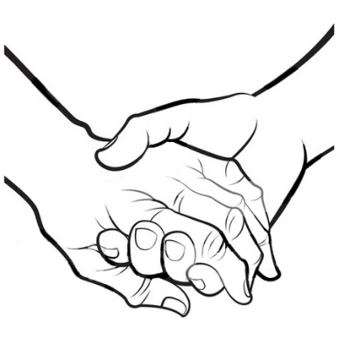
Is the Befriending Service Right for you?

What is this service?
Carefully vetted volunteers are matched with older Barnet residents. These volunteers will visit you in your home for regular companionship and emotional support for a period of six months or more.

Am I eligible?
- Are you over 55 years of age and live in the borough of Barnet?
- Are you on your own for long periods of time and miss having someone to talk to?
- Do you have disabilities that make it hard for you to contact others?
- Do you think you could form a rewarding relationship with a volunteer and be able to make and keep regular appointments?

Who do I contact if I want to learn more about the service?
Sian Jones  Befriending Manager  Ann Owens Centre  Oak Lane  East Finchley, N2 8LT | Hours  Monday to Thursday
Tel No: 020 8432 1416  Mobile: 07505 089 129 | Email: sian.jones@ageukbarnet.org.uk

Alternatively, a referral form can be downloaded from www.ageukbarnet.org.uk and emailed back to Sian by you or by someone on your behalf.
What happens next?
- The Befriending Manager will telephone you to check that the service can meet your needs and if not suggest alternatives such as community based activities or telephone befriending.
- If the service is appropriate, the manager will arrange to visit you in your home. This will enable her to get to know you better so she can start looking for the right volunteer and take details of who to contact if you are ill or have an accident.
- She will discuss with you what will be safe and possible for you and a volunteer to do together.
- She will discuss how long you might have to wait until a volunteer is found.
- At the end of the meeting you will need to sign a form. This form explains how we store and use the information you have given us.
- You will receive a call when a suitable volunteer is found and the manager will arrange to introduce the volunteer to you.
- If you are happy with the chosen volunteer, they will start to visit you at an agreed time.
- During the early weeks your match will be closely monitored in case either you or the volunteer feel something needs to be changed.
- Waiting times for assessment and matching can vary according to demand and the availability of suitable volunteers.

What can I ask my visitor to do?
- Provide companionship. This means exchanging stories, a joke and if you wish it, discussing your feelings and opinions on many subjects from the weather to life changing events.
- Telephone you each week to confirm the next visit.
- If risk assessed and agreed in advance, volunteers may;
  - Go with you to the shops, park, or appointments and in some cases take you there in their own cars.
  - Play games or go through old photos and paper work.
  - Write a letter, access the internet and many other mutually agreed tasks.

What can I not expect my volunteer to do?
- Replace a service you would normally pay for e.g. regular cleaning or personal care. This also includes jobs that require professional qualifications such as electrical repairs and plumbing.
- Provide an essential service such as regular food shopping.
- Take on any task the volunteer may be unable to do because they have other commitments.
- Carry out any task that could put either of you at risk.
- Give you their personal contact details as you will be able to contact them via a 24 hour mobile number serviced by Age UK Barnet 07505 089129.
- Accept money and gifts from you unless it is repayment for an agreed outlay like occasional shopping or parking.

What might you hope to gain from Befriending?
- Feel less lonely, knowing there is someone you can talk to about your concerns and interests. Provide a new audience for your stories and make you feel you have something of value to offer others.
- Many say their volunteer is a “window to the world” and helps them feel less isolated. They feel more confident chatting to others as they have something new to talk about and there is something to look forward to.
- Some volunteers may be able to help you safely venture outside your home.
- Someone can help look up information using their mobile telephone or assist you with modern technology. As they come regularly, it does not matter if they have to repeat instructions and you may make more progress and can surprise family and friends with your new skills.
- Help you find help and services before issues become major problems.
- There is someone to help sort paperwork and read mail or other little tasks.

What does the volunteer gain from their visits to you?
Our volunteers vary in age from 16 to 80+ years and have widely different backgrounds. Volunteers frequently feel they benefit as much as you from these visit. They tell us that they:

- Miss having contact with older relatives.
- Enjoy hearing about your life experiences.
- Enjoy making a new friend who is out of their usual circle of acquaintances.
- Feel they are helping someone, so it is important you give them positive feedback. If the feedback is less than positive you should tell the befriending manager.
- Enjoy learning new skills
- Believe the experience may help them apply for training in medicine or social care.

Do I pay for this service?
No the service is free but donations to Age UK Barnet are very welcome and are used to reimburse the volunteers for their expenses and other service expenses.

When you receive the service you can also help by;
- Answering telephone or written questionnaires about the service when contacted by one of our team. Feedback helps us to improve the service and retain or increase our funding to help others.
- Keep us informed of any changes to your circumstances such as new phone numbers, email addresses, illness, hospital stays, holidays or if you plan to move home.

If you have any further questions or complaints, please contact Sian Jones, Befriending Manager or Mark Robinson, Chief Officer, Age UK Barnet on 020 8203 5040.

