Age UK Barnet

Crisis and Resilience Fund - Interim
  - Guidance for Professional Referrers (Jun & Jul 2026/27)
The primary aim of our Crisis and Resilience Fund (CRF) scheme is to provide timely financial assistance to households experiencing an immediate crisis or emergency. Alongside this, we offer holistic, wrap-around support to address the underlying causes of financial hardship and help individuals establish greater financial resilience and stability over the medium-to-long term.
Please kindly note that this scheme is currently provisional and may be subject to changes in the future.

Eligibility Criteria
We welcome referrals for Barnet Residents aged 55 and over who meet the following criteria:

Primary Criteria: Experiencing an Immediate Crisis
The individual or household’s circumstances have unexpectedly changed, and they are now facing a sudden, unexpected expense or drop in income which cannot be reasonably met from their available income, savings or capital.
These costs/loss of income might have arisen from situations including but not limited to:
- disasters - these will normally be unforeseen and result in significant damage to, or loss of, possessions or property, such as a serious flood or fire, gas explosion or a chemical leak
- accident, health emergency or mental health crisis, leading to unplanned spending or incurring increased expenses
- when an applicant is experiencing domestic abuse and leaving an abusive relationship/partner and needs immediate help, such as moving into an unfurnished property and needing help with furniture and appliances
- breakage of an essential item, for example a boiler, medical equipment or white goods
- where money has been lost or stolen and living expenses are required
- when the applicant has a short-term gap in regular income, for example, due to redundancy or a significant change in working pattern

Secondary Criteria
All of the following criteria must also be met:
- Accessible personal / household savings and capital lower than £2,000.
- Having a household income lower than 1.2x the Minimum Income Standard (after housing costs)
- No access to other relevant sources of funding (e.g., Utility provider grants to clear arrears, CRF Housing Payments from Barnet Council)
- Not having received a Barnet Resident Support Fund or Household Support Fund award, or a Crisis Payment (including from Age UK Barnet or BOOST) for the same purpose and without a significant change in circumstances
- Having no restrictions to access UK Public Funds

Referral Process

Submitting a Professional Referral
Please fill in and submit our online CRF Professional Referral Form here. We ask that all referrers please confirm on the form that the customer meets all of the above eligibility criteria.

Request for Supporting Documents
Our CRF Team will send an email to acknowledge the referral and issue a unique CRF customer number. We aim to respond to all referrals within 5 working days, however at times of high demand this may take longer.
A secure ‘File Request’ Drop-Box link will be included in the email inviting the referrer to upload the supporting documents.
If the customer opted to directly provide their supporting documents, we will copy the customer in our email.

Sending Supporting Documents
The referrer or customer must provide supporting documents within 2 weeks of the date of our acknowledgement email.
If documents are not received within this timeframe, the application will be treated as if withdrawn. If the customer anticipates that obtaining their documents will take longer than this, they may request that this deadline be extended by a further 2 weeks.
Documents can be uploaded using the ‘File Request’ link OR by posting to our office to:
CRF Team, Age UK Barnet, Ann Owens Centre, Oak Lane, London N2 8LT.

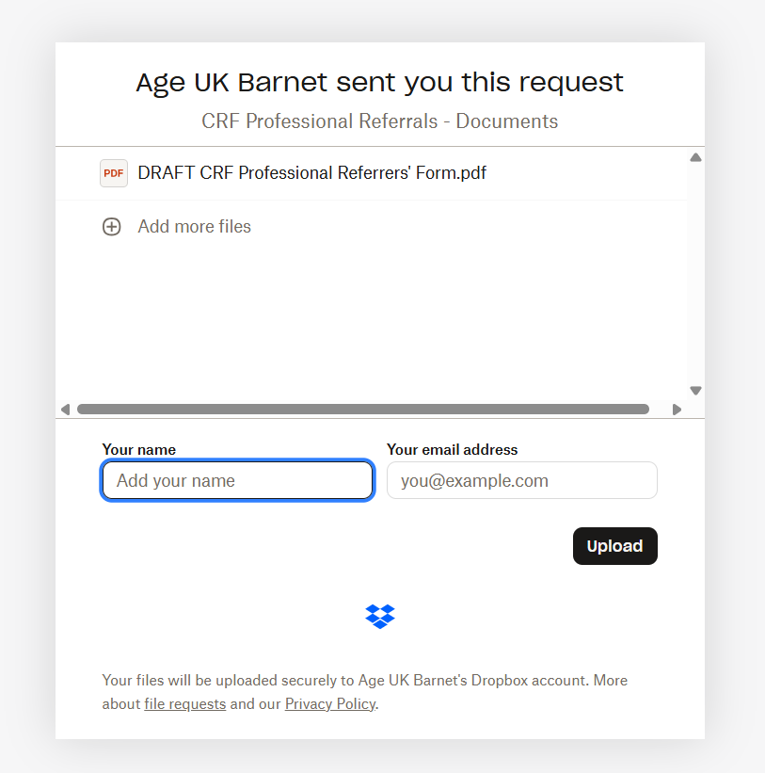
Please record customer’s CRF Number and last name here instead of your name
Filename.pdf
The above image shows the upload screen you will see right before submitting the documents. In the field marked ‘Your Name’, please instead put the customer’s CRF number and their last name.
IMPORTANT: Please ensure all communications and documents are marked with the customer’s unique CRF number. We will not respond to communications or assess digital or printed documents without a valid CRF number.
Required supporting documents:
- Proof of all sources of household income (such as: bank statement, Universal Credit letter, evidence of any other benefits)
- Evidence of the client's rent/mortgage costs, if not shown on the bank statement or UC letter
- Proof of total household savings/investments/capital
- Evidence of the crisis they are facing (such as: letter of redundancy, eviction notice, debt collection letter, quote for urgent repairs)

Referral ‘Completed’
A referral is considered as ‘completed’ when all relevant information and supporting documents have been received within the time frame.
Our CRF Team will only assess completed referrals.

Assessment
At this stage, the application and documents will be reviewed and will fall under one of the 3 following scenarios:

Scenario 1 – The Customer Meets the Eligibility Criteria
Our CRF Team will contact the customer to verify their personal details and payment method preference.
Crisis payment will be issued within 2 working days following a confirmation from the CRF Team.
The CRF Team will act as triage for the individual / household to access our Resilience & Recovery support team.

Scenario 2 – More Information Required
In the even that only some of the required documents are received, or if the wrong documents are received, our CRF Team will contact the customer to request further supporting evidence. The customer will be given an additional 2 weeks to supply this.
The CRF Team will then assess the complete referral following the steps outlined in Scenario 1.

Scenario 3 – Insufficient Information and/or Supporting Documents OR Criteria Not Met
A referral would be in this scenario when the professional or the customer failed to provide sufficient information or supporting documents within the timeframe OR if the customer is assessed as not meeting the criteria.
The CRF team will inform the customer of our decision, and act as triage for the customer to access our Later Life Planning service.
Our Later Life Planning Information & Advice service hold the Advice Quality Standard (AQS) and are accredited by Advice Services Alliance.
Email: LaterLifePlanners@ageukbarnet.org.uk
Direct helpline: 020 8432 1417 (open Mon-Thu 1000 – 1300)

Our Two-Stage CRF Approach
There are two stages to our CRF scheme:
- Stage 1: Crisis Support
- Stage 2: Resilience and Recovery Support

Stage 1: Crisis Support
All “completed” referrals will be assessed by our CRF Team to determine if the customer met the primary and secondary eligibility criteria. When a referral is assessed as meeting the criteria, Crisis Payment will be arranged.

What is a Crisis Payment?
Crisis Payments are one-off financial support to provide short-term relief for immediate crises, or to prevent the customer from entering an imminent crisis. It is intended to address immediate financial shocks only and should not be treated as an alternative source of income.
We offer 2 types of Crisis Payment:
- Fixed Crisis Payments
- Discretionary Crisis Payments

Fixed Crisis Payments
This one-off payment will be awarded to most customers who meet the eligibility criteria.
The value of the fixed payment will vary depending on the customer’s household and living arrangement.
Age Group | Single | Couple
Working Age / Mixed-Age | £350 | £600
State Pension Age | £250 | £550

Discretionary Crisis Payments
Larger amounts may be awarded on a discretionary basis if the customer’s circumstances warrant this. Examples of extenuating circumstances include but are not limited to:
- Moving into unfurnished social accommodation
- Boiler repairs
- Applying for a financial deputyship
It is particularly important that requests for additional support are accompanied by documentary evidence of the problem at hand.

Expected Timeframes
The CRF Team aims to issue Fixed Crisis Payments within 2 working days of a complete application to eligible customers, and Discretionary Crisis Payments within 2 weeks.

Accessibility and Customer Preferences
Crisis Payments will be cash payments by default (via bank transfer or PayPoint vouchers) with the exception that an alternative form or payment is preferred or is deemed more suitable.
Some examples of reasons why another method may be preferable are:
- If the customer has underlying conditions not suiting large amounts of cash (such as gambling or substance addictions)
- If the customer stated a preference for shopping vouchers or a payment made to their utility provider on their behalf.
Alternative payment methods could be:
- Supermarket vouchers
- Payments direct to a utility provider
- Energy meter top-up vouchers

Stage 2: Resilience & Recovery Support
Customers who receive a Crisis Payment will be triaged by our CRF Team to access our Resilience and Recovery Support Service. The aim is to prevent occurrence, recurrence, escalation of crises and support to develop skills, knowledge, coping strategies, and resilience to unexpected changes in the future.
This may include:
- Income maximisation and benefits advice
- Accessing social care and home adaptations
- Accessing housing support and advice
- Accessing debt advice and/or legal advice
- Accessing life-skills educational courses – including budgeting, managing money, cooking classes
- Accessing employment support services
- Accessing food banks
- Accessing up-skill educational courses – including English courses for non-English speakers and adult courses
- Accessing IT and digital support
- Accessing other grants
- Direct referrals / signpost to other services, such as social and hobby activities
The Resilience & Recovery Support team may offer additional discretionary help toward the cost / fee to access the above services, if it is deemed necessary.

Additional Information

Advice for Making Successful Referrals
Because Crisis Payments are limited to those who have an identifiable short-term shock that needs addressing, it is important to let us know if you think this is something your client is facing.
To be considered for a Crisis Payment, please tell us in detail:
- What hardship the client is experiencing
- Why they cannot cover their expenses
If this information is not provided, the client is unlikely to be awarded a Crisis Payment.

Requesting a Review of a Decision
The Crisis Payment scheme is discretionary, and decisions on a CRF award do not carry a right of appeal to a Social Security Tribunal. However, we understand that some customers and referrers may wish for clarification on how the decision on their application was made. If requested, we will review and/or explain the full steps that led to the decision made.
This will include:
- A breakdown of each of the scheme’s eligibility criteria, which criteria the customer met/did not meet, and why
- If the reason for an unsuccessful application was that the customer’s income or savings were too high, a breakdown of how the customer’s total weekly income or savings threshold was calculated
- For successful the customers, how we calculated how much support they were entitled to.
- If upon further investigation we learn that an error was indeed made, we will re-assess the application and award (additional) support if appropriate.
- To request a review, please email support@ageukbarnet.org.uk.

Individuals must have been resident in Barnet for at least 12 months, or have been placed in temporary accommodation out of borough by Barnet Homes
Savings are considered accessible if there are no barriers to withdrawing the savings beyond visiting the bank or accessing an online bank account. Savings are still considered accessible even if there are fees applied for withdrawing the savings (e.g., withdrawing from a fixed term savings account early and forfeiting interest) provided that these fees are small relative to the amount in savings. If the customer is unable to release money on assets they own immediately but can demonstrate that they are taking steps to do so, CRF support may be appropriate in the interim.
For more information please see https://www.jrf.org.uk/a-minimum-income-standard-for-the-united-kingdom-in-2025
We will consider applications for this provided that the application was submitted no later than 8 weeks after the customer has moved into the new property.

