Lunch Menu
Mains

- Vegetable frittata served with
garlic bread and roasted tomato
Allergens – Milk, egg & wheat

Pudding
Pear chocolate upside down cake
serve with cream (V)
or
Allergens – wheat, milk & egg
Fruit of the day
or
Sugar free jelly or (V)
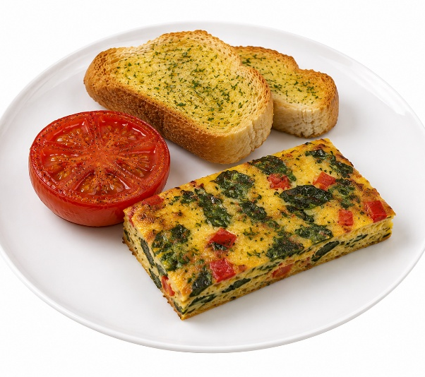 | Vegetable frittata served with garlic bread and roasted tomato
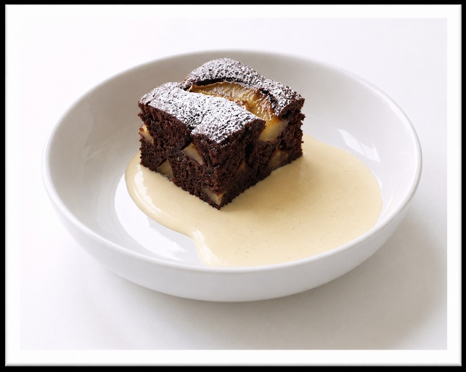 | Pear chocolate  upside down cake  serve with cream(V)  or  Fruit of the day  or  Sugar free jelly

