Lunch Menu
Mains
- Fish pie served with salad
Allergens – Fish, wheat, egg,
milk, mustard & sulphite
Vegetarian
- Mozzarella & lentils salad (V)
Allergens – Milk, mustard & sulphite

Pudding
Banana cake served with ice cream(V)
Allergens – wheat, egg, soya & milk
or
Fruit of the day
or
Sugar free jelly
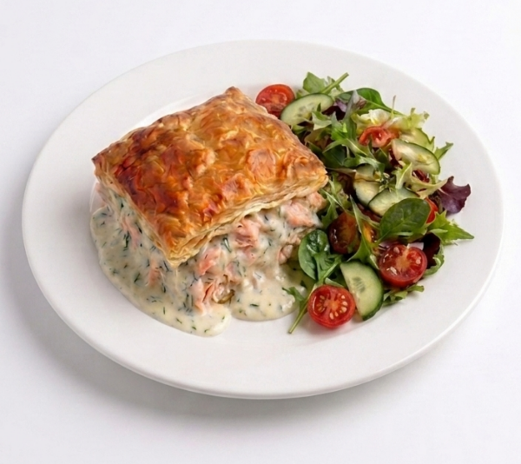 | Fish pie served with salad
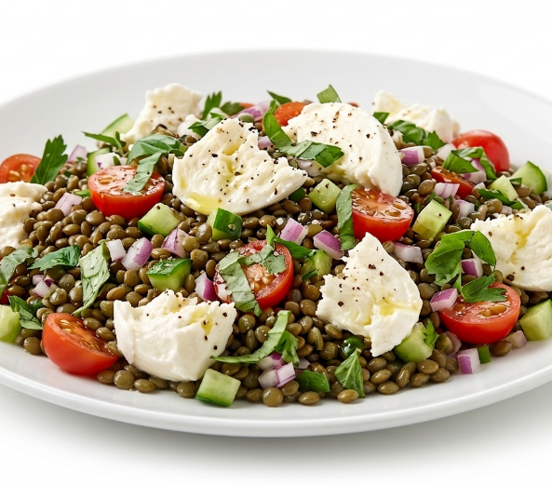 | Mozzarella lentils salad (V)
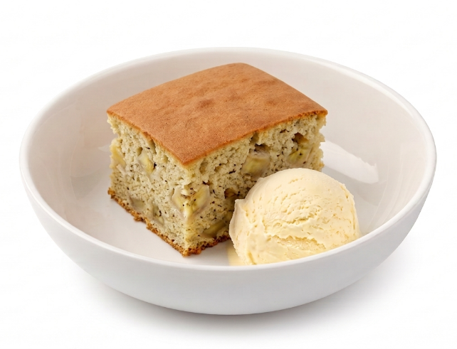 | Banana cake served with ice cream(V)  or  Fruit of the day  or  Sugar free jelly

