Lunch Menu
Mains
- Beef spaghetti Bolognese
served with green bean
Allergens – Wheat, milk & celery
Vegetarian
- Lentils spaghetti Bolognese
served with green bean (V)
Allergens – Wheat, milk & celery
or
- Quorn nuggets served with gravy,
mashed potato & green bean (V)
Allergens – Wheat, soya, egg & milk
Pudding
- Lemon drizzle cake served with custard (V) or
Allergens – wheat, milk & egg
Fruit of the day or
Sugar free jelly or (V)
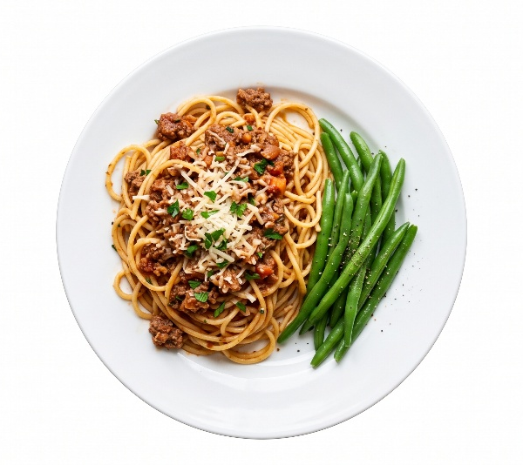 | Beef spaghetti Bolognese  served with green bean
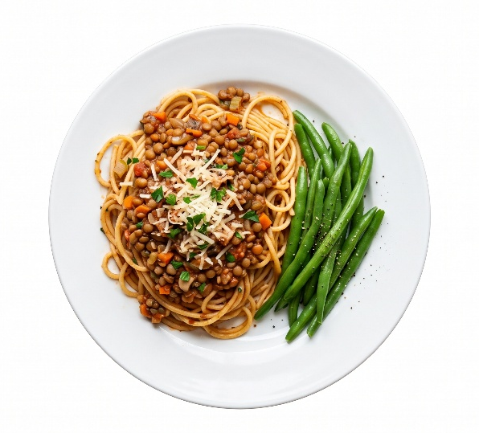 | Lentils spaghetti Bolognese served with green bean (V)
 | Lemon drizzle cake  served with custard (V) or  Fruit of the day  or  Sugar free jelly

