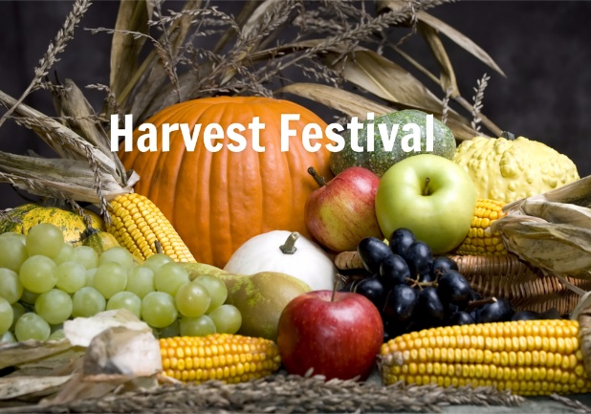
Day Opportunities Daily Planner
Harvest Festival
Date 08/10/2025
Time | Activity
10:00 – 11:00 | Tea & Coffee Morning
11.00 – 12:00 | Group 1  Senior Singers with Jenny  @ 11:15 – 12:15 | Group 2  Creating Leaf Pictures
12:00 -12:30 | Group 1  Seated Yoga | Group 2  Discussion on Harvest  Festival
12:30 -13:30 | Lunch
13:30- 14:30 | Group 1  Cognitive stimulation | Group 2  Jeopardy Quiz
14:30 -15:00 | Enjoy the Music

