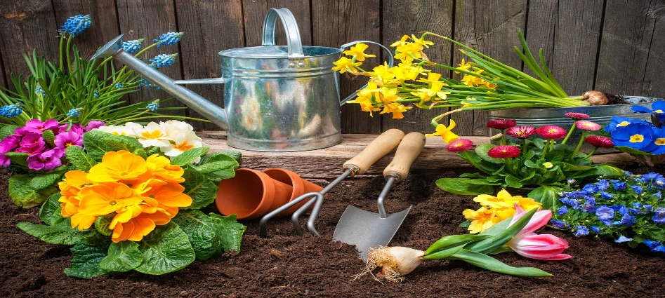
Day Opportunities Daily Planner

Date 10/08/2026

Time | Activity |  | Lead
10:00 – 11:00 | Coffee & Tea Morning
11.00 – 12:00 | Group 1  Summer gardening | Group 2  Make a candle holder out of clay | &  Volunteers
12:00-12:30 | Group 1  Cognitive stimulation | Group 2  Seated Yoga | &  Volunteers
12:30-13:30 | Lunch |  | San
13:30-14:30 | Group 1  General knowledge quiz | Group 2  Match the card game | &  Volunteers
14:30- 15:00 | Enjoy the music |  | Everyone

