Lunch Menu
Mains
- Beef meatball served with tomato sauce, rice & broccoli
Allergens – Celery, wheat & sulphite
(Vegetarian Swedish style ball also available)
(Allergens – Celery, barley, egg & wheat)
Vegetarian
- Vegetarian chilli con carne served with rice, yogurt & broccoli (V)
Allergens – Wheat, barley, celery & milk
Pudding
Munchmallow cake (V)
Allergens – wheat, soya, egg & milk
or
Fruit of the day or Sugar free jelly
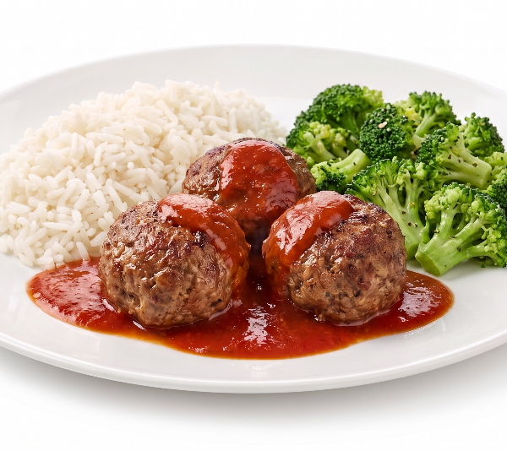 | Beef meatball served with tomato sauce, rice & broccoli  (Vegetarian Swedish style ball also available)
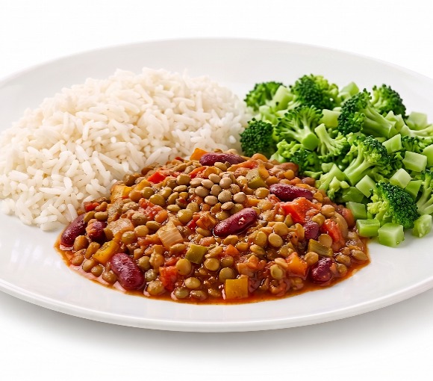 | Vegetarian chilli con carne served with rice, yogurt & broccoli (V)
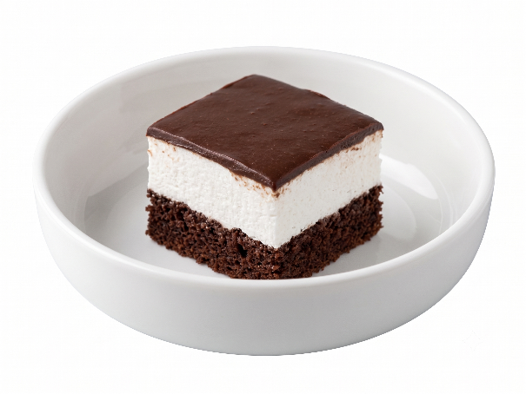 | Munchmallow cake (V) or  Fruit of the day  or  Sugar free jelly

