Lunch Menu
Mains
- Pork sausages served with mashed potato, pea & gravy
Allergens – Wheat, sulphites, soya & celery
Vegetarian
- Vegan sausages served with mashed potato, pea & gravy (V)

Allergens – Soya, milk, sulphite & celery

Pudding
- Cake of the day
served with ice cream (V)
Allergens – Wheat, egg, soya & milk
or
Fruit of the day or sugar free jelly
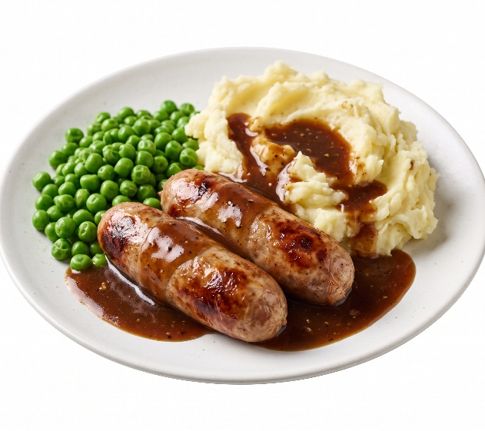 | Pork sausages served with mashed potato, pea & gravy
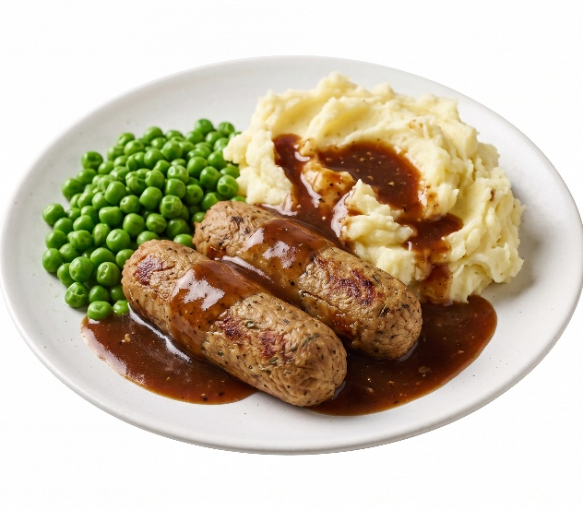 | Vegan sausages served with mashed potato, pea & gravy (V)
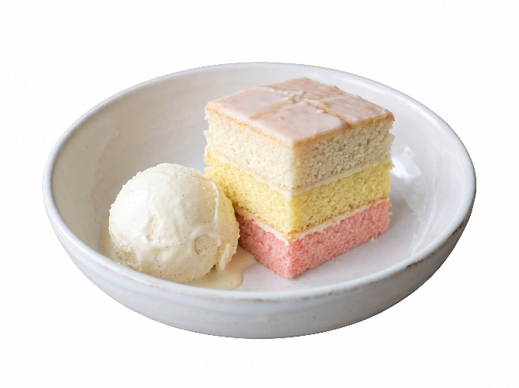 | Cake of the day  served with ice cream (V) or  Fruit of the day  or  sugar free jelly

