Lunch Menu
Mains
- Fish stew served with garlic bread
Allergens – Wheat, fish, milk & celery
Vegetarian
- Bean stew served with
garlic bread (V)
Allergens – Wheat, milk & celery
or
- Mozzarella stick served with
vegetables of the day & garlic bread (V)
Allergens – Wheat, soya, egg & milk
Pudding
- Dried fruit cake served with custard (V) or
Allergens – wheat, milk, sulphite & egg
Fruit of the day or
Sugar free jelly (V)
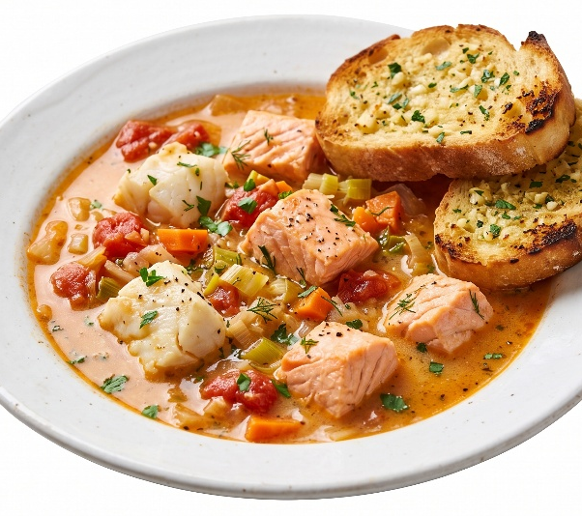 | Fish stew served with garlic bread
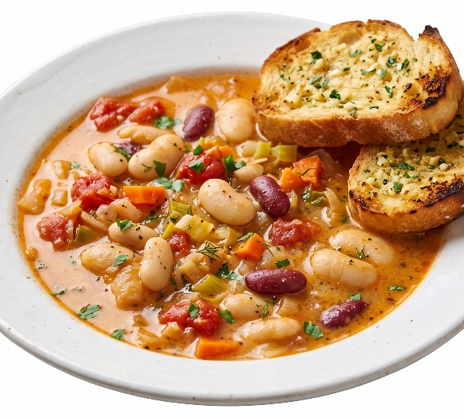 | Bean stew served with  garlic bread (V)
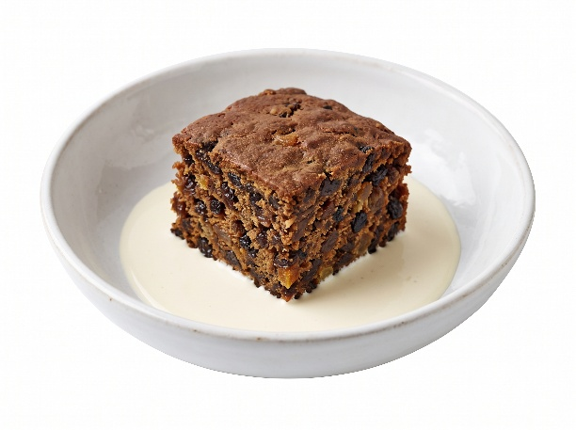 | Dried fruit cake served with custard (V) or  Fruit of the day  or  Sugar free jelly

