Lunch Menu
Mains
- Bake fish & vegetables served with roasted carrot & new potatoes
Allergens – Fish & milk
Vegetarian
- Cheese omelette served with roasted carrot & new potatoes (V)

Allergens – Egg & milk

Pudding

- Dried fruit cake & carrot cake
served with cream (V)
Allergens – Wheat, egg & milk
or
Fruit of the day or
sugar free jelly
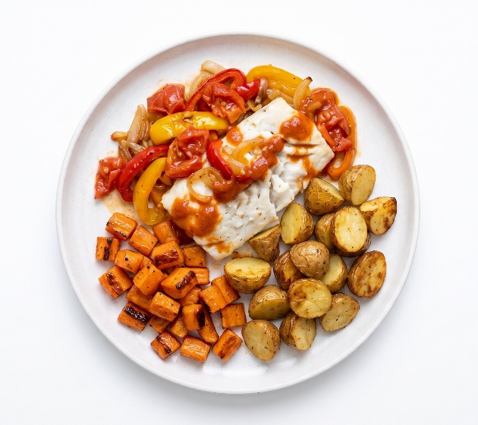 | Bake fish & vegetables served with roasted carrot & new potatoes
 | Cheese omelette served with roasted carrot & new potatoes (V)
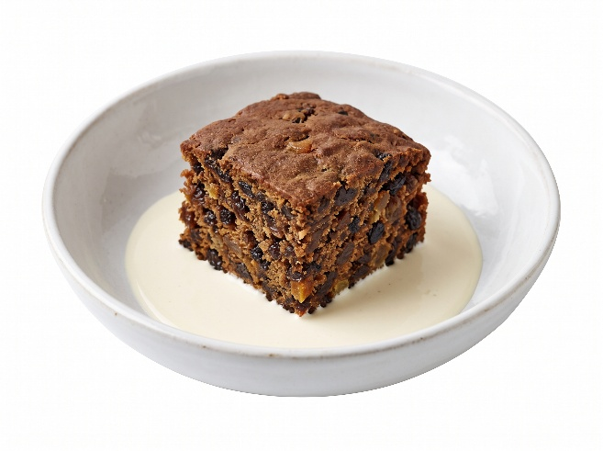 | Dried fruit cake & carrot cake served with cream (V)  or  Fruit of the day  or  sugar free jelly

