Lunch Menu
Mains
- Beef Lasagna served with cabbages
Allergens – Wheat, milk & celery
Vegetarian
- Vegetarian Lasagna
served with cabbages (V)
Allergens – Wheat, soya, barley, milk & celery
or
- Cheese Croquettes served with cabbages, mash & gravy (V)
Allergens – Wheat, soya, egg & milk
Pudding
- Pumpkin pie served with cream (V) or
Allergens – wheat, milk & egg
Fruit of the day or
Sugar free jelly (V)
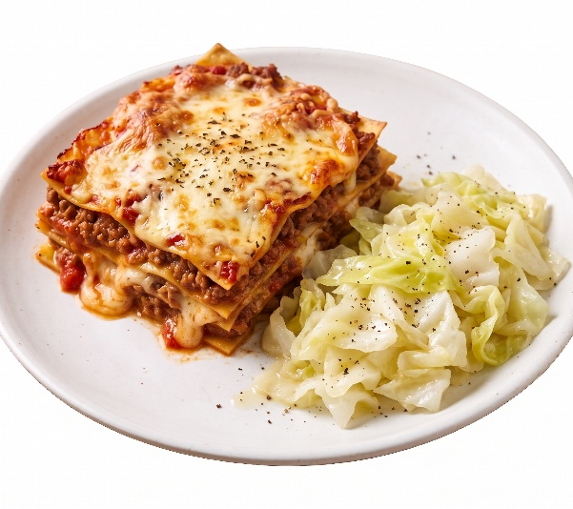 | Beef Lasagna served with cabbages
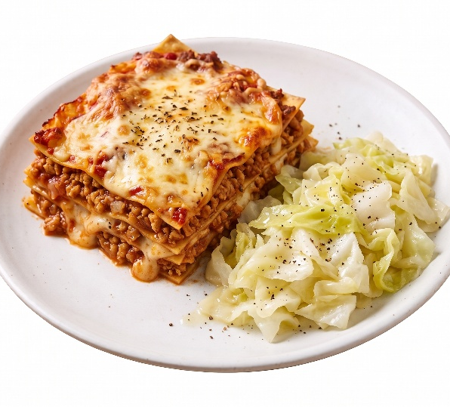 | Quorn Lasagna served with cabbages (V)
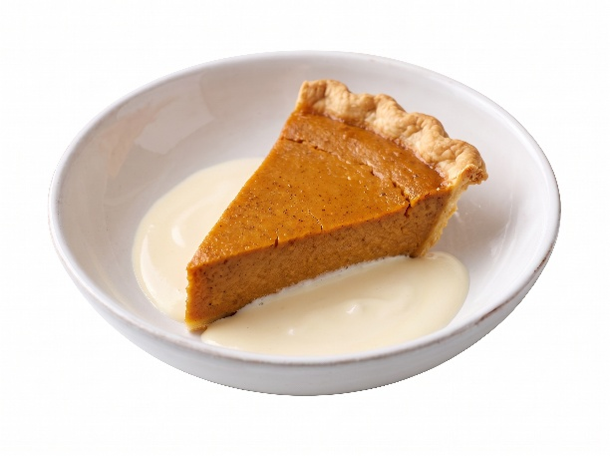 | Pumpkin pie served with cream (V)  or  Fruit of the day  or  Sugar free jelly

