Age UK Barnet

Crisis and Resilience Fund
  - Guidance for Professional Referrers (October 2026-March 2027)
The primary aim of our Crisis and Resilience Fund (CRF) scheme is to provide timely financial assistance to households experiencing an immediate crisis or emergency. Alongside this, we offer holistic, wrap-around support to address the underlying causes of financial hardship and help individuals establish greater financial resilience and stability over the medium-to-long term.
Please kindly note that this scheme is currently provisional and may be subject to changes in the future.

Eligibility Criteria
We welcome referrals for Barnet Residents aged 55 and over who meet the following criteria:

Primary Criteria: Crisis
One of the following statements must apply:
- The client has experienced a sudden and unexpected financial shock – that is, a sudden loss of income or unexpected expense – in the last 12 weeks
- The client is likely to be unable to afford access to material essentials (food, warmth) in the next 12 weeks. This will be assessed based on their income and whether the client is struggling with priority debts.

Secondary Criteria
All of the following criteria must also be met:
- Accessible personal / household savings and capital lower than £6,000 OR if substantial home repairs or priority debt repayments are required and paying for these would leave the client with less than £6,000
- Having a household income lower than 1.2x the Minimum Income Standard (after housing costs)
- No access to other relevant sources of funding (e.g., Utility provider grants to clear arrears, CRF Housing Payments from Barnet Council)
- Not having received a Barnet Resident Support Fund or Household Support Fund award, or a Crisis Payment (including from Age UK Barnet or BOOST) for the same purpose and without a significant change in circumstances
- Having no restrictions to access UK Public Funds

How to Apply

Submitting a Professional Referral
- Please fill in and submit our online CRF Professional Referral Form here. We ask that all referrers please confirm on the form that the client meets all of the above eligibility criteria.
- Our CRF Team will send an email to acknowledge the referral and issue a unique CRF client number. We aim to respond to all referrals within 5 working days, however at times of high demand this may take longer.
  - A secure ‘File Request’ Drop-Box link will be included in the email inviting the referrer to upload the supporting documents.
  - The referrer or client must provide supporting documents within 2 weeks of the date of our acknowledgement email.
  - If documents are not received within this timeframe, the application will be treated as if withdrawn. If the client anticipates that obtaining their documents will take longer than this, they may request that this deadline be extended by a further 2 weeks.
Documents can be uploaded using the ‘File Request’ link OR by posting to our office to:
CRF Team, Age UK Barnet, Ann Owens Centre, Oak Lane, London N2 8LT.

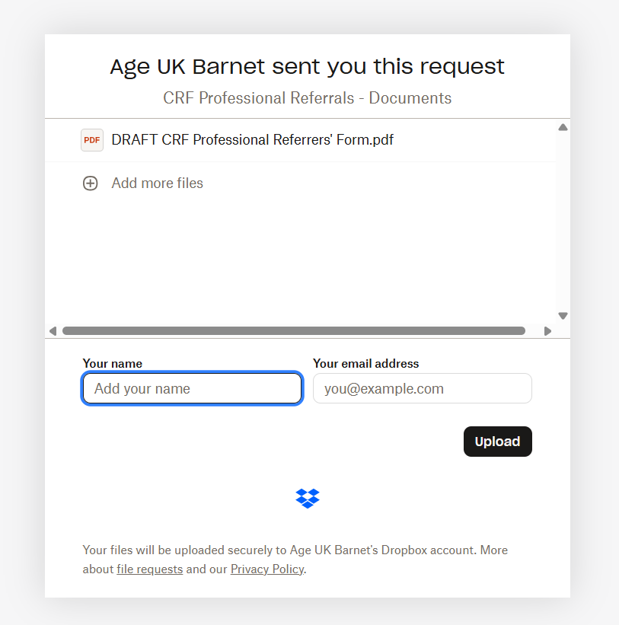
Please record client’s CRF Number and last name here instead of your name
Filename.pdf
The above image shows the upload screen you will see right before submitting the documents. In the field marked ‘Your Name’, please instead put the client’s CRF number and their last name.
IMPORTANT: Please ensure all communications and documents are marked with the client’s unique CRF number. We will not respond to communications or assess digital or printed documents without a valid CRF number.
Required supporting documents:
- Proof of all sources of household income (such as: bank statement, Universal Credit letter, evidence of any other benefits)
- Evidence of the client's rent/mortgage costs, if not shown on the bank statement or UC letter
- Proof of total household savings/investments/capital
- Evidence of the crisis they are facing (such as: letter of redundancy, eviction notice, debt collection letter, quote for urgent repairs)

Crisis Payments
Crisis Payments are one-off financial support to provide short-term relief for immediate crises, or to prevent the client from entering an imminent crisis. It is intended to address immediate financial shocks only and should not be treated as an alternative source of income.
Crisis payments will typically be awarded for fixed amounts, as shown in the below table:
Age Group | Single | Couple
Working Age / Mixed-Age | £350 | £600
State Pension Age | £250 | £550

Larger amounts may be awarded on a discretionary basis if the client’s circumstances warrant this. These will be awarded where:
- There is a clear external cost which needs to be addressed
- Not addressing this cost would limit the client’s access to warmth, food, or threaten their physical safety
- This cost can be quantified, for example, by a professional quote for repairs. Documentary evidence of this will be required.
Examples of such extenuating circumstances include but are not limited to:
- Moving into unfurnished social accommodation
- Boiler repairs
- Applying for a financial deputyship

Expected Timeframes
The CRF Team aims to issue Fixed Crisis Payments within 2 working days of a complete application to eligible clients, and Discretionary Crisis Payments within 2 weeks.

Accessibility and Client Preferences
Crisis Payments will be cash payments by default (via bank transfer or PayPoint vouchers), unless another method is preferred, for example, because:
- The client has underlying conditions not suiting large amounts of cash (such as gambling or substance addictions)
- The client has stated a preference for shopping vouchers or a payment made to their utility provider on their behalf.
Alternative payment methods could be:
- Supermarket vouchers
- Payments direct to a utility provider
- Energy meter top-up vouchers

Resilience Support
Clients who receive a Crisis Payment will be triaged by our CRF Team to access our Resilience and Recovery Support Service. The aim is to prevent occurrence, recurrence, escalation of crises and support to develop skills, knowledge, coping strategies, and resilience to unexpected changes in the future.
This may include:
- Income maximisation and benefits advice
- Accessing social care and home adaptations
- Accessing housing support and advice
- Accessing debt advice and/or legal advice
- Accessing life-skills educational courses – including budgeting, managing money, cooking classes
- Accessing employment support services
- Accessing food banks
- Accessing up-skill educational courses – including English courses for non-English speakers and adult courses
- Accessing IT and digital support
- Accessing other grants
- Direct referrals / signpost to other services, such as social and hobby activities
The Resilience Support team may offer additional discretionary help toward the cost / fee to access the above services, if it is deemed necessary.

Additional Information

Advice for Making Successful Referrals
Because Crisis Payments are specifically intended for those who have an identifiable short-term shock that needs addressing, it is important to let us know if you think this is something your client is facing.
To be considered for a Crisis Payment, please tell us in detail:
- What hardship the client is experiencing
- Why they cannot cover their expenses
If this information is not provided, the client is unlikely to be awarded a Crisis Payment.

Requesting a Review of a Decision
The Crisis Payment scheme is discretionary, and decisions on a CRF award do not carry a right of appeal to a Social Security Tribunal. However, we understand that some clients and referrers may wish for clarification on how the decision on their application was made. If requested, we will review and/or explain the full steps that led to the decision made.
This will include:
- A breakdown of each of the scheme’s eligibility criteria, which criteria the client met/did not meet, and why
- If the reason for an unsuccessful application was that the client’s income or savings were too high, a breakdown of how the client’s total weekly income or savings threshold was calculated
- For successful the clients, how we calculated how much support they were entitled to.
- If upon further investigation we learn that an error was indeed made, we will re-assess the application and award (additional) support if appropriate.
- To request a review, please email support@ageukbarnet.org.uk.

Individuals must have been resident in Barnet for at least 6 weeks, or have been placed in temporary accommodation out of borough by Barnet Homes
This will be assessed based on the client’s income – any client with an income of 75% of the Minimum Income Standard or lower will meet this threshold. For more information, please see note [4].
If the client is unable to release money on assets they own immediately but can demonstrate that they are taking steps to do so, CRF support may be appropriate in the interim.
For more information, please see https://www.jrf.org.uk/a-minimum-income-standard-for-the-united-kingdom-in-2025
We will consider applications for this provided that the application was submitted no later than 12 weeks after the applicant has moved into the new property. The amount awarded in the event of a successful application will typically be a maximum award of £1,500.00

