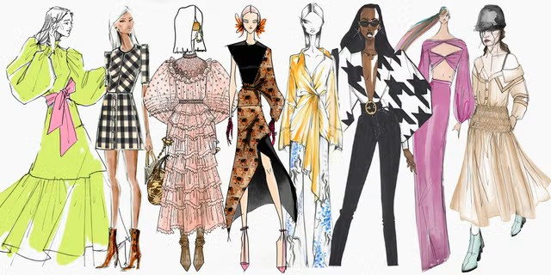
Day Opportunities Daily Planner
Fashion Week
Date 19/08/2026
Time | Activity |  | Lead
10:00 – 11:00 | Tea & Coffee Morning
11:00 – 12:00 | Group 1  Yoga with Vandana | Group 2  Art & Design:  Collage with Fabric
12:00 - 12:30 | Group 1  Quiz about Fashion, Models & Designers | Group 2  Flower Arranging
12:30 - 13:30 | Lunch
13:30 - 14:30 | Group 1  Art & Craft:  Making Fascinator | Group 2  Wordsearch: Coco Chanel &  My Clothes
14:30 - 15:00 | Songs & Music |  | Everyone

