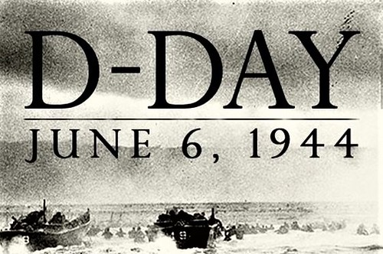
Day Opportunities Daily Planner
D Day/World Music Week
Date 05/06/2026
Time | Activity |  | Lead
10:00 – 11:00 | Tea & Coffee Morning
11:00 – 12:00 | Group 1  Music Performance with Jenny | Group 2  Arts & Crafts:  Patriotic Decoupage
12:00 - 12:30 | Group 1  Seated Exercise | Group 2  Wordsearch: Around the World Through Music
12:30 - 13:30 | Lunch
13:30 - 14:30 | Group 1  Art Session with Nimu | Group 2  World Music Quiz
14:30 - 15:00 | Music & Birthday Celebration |  | Everyone

