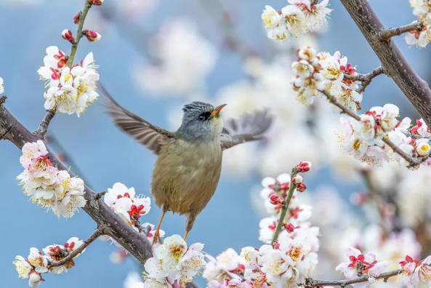
Day Opportunities Daily Planner

Date 01/06/2026
Time | Activity |  | Lead
10:00 – 11:00 | Tea & Coffee Morning
11:00 – 12:00 | Group 1  Making Apple Bird Feeder | Group 2  Gardening/General  Knowledge Quiz
12:00 - 12:30 | Group 1  Seated Exercise | Group 2  Wordsearch: Birds
12:30 - 13:30 | Lunch
13:30 - 14:30 | Group 1  Painting by Number:  Birds of a Feather | Group 2  Bird Bingo
14:30 - 15:00 | Music & Birthday Celebration |  | Everyone

