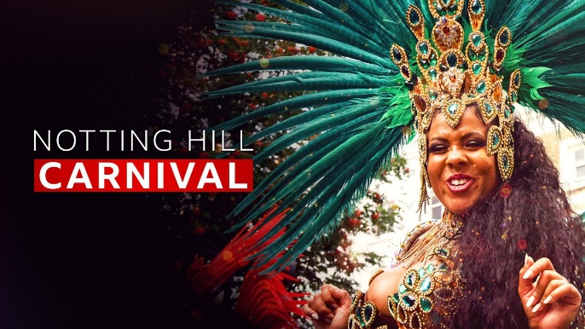
Day Opportunities Daily Planner
Carnival Week
Date 25/08/2025
Time | Activity |  | Lead
10:00 – 11:00 | Tea & Coffee Morning
11:00 – 12:00 | Group 1  Carnival Food:  Make Virgin Pina Colada & Nachos | Group 2  Quiz about Carnivals  around the World
12:00 - 12:30 | Group 1  Seated Exercise | Group 2  Wordsearch: Carnival
12:30 – 13:30 | Lunch
13:30 – 14:30 | Group 1  Arts & Craft:  Create Carnival Mask | Group 2  Caribbean Sensory Tray:  Spices & Scents
14:30 – 15:00 | Birthday Celebration & Music |  | Everyone

