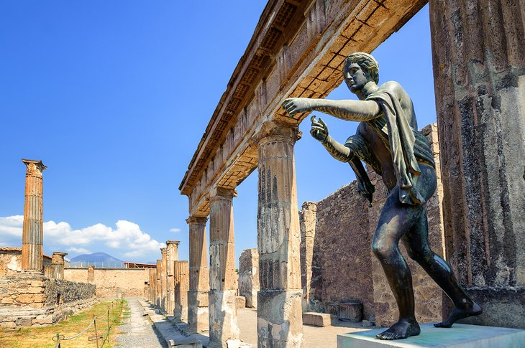
Day Opportunities Daily Planner
Italian Week
Date 28/05/2025
Time | Activity
10:00 – 11:00 | Tea & Coffee Morning
11:00 – 12:00 | Group 1  Preparing Taster Session Pizza & Tiramisu | Group 2  Yoga 11:00-11:45
12:00 - 12:30 | Group 1  Arm Chair Tour of Italy | Group 2  Italian Food Trivia
12:30 - 13:30 | Lunch
13:30 - 14:30 | Group 1  Cognitive Stimulation | Group 2  Famous Italians
14:30 - 15:00 | Italian Taster Session

