Lunch Menu
Mains
- Chickpea tagine served roasted chicken & couscous
Allergens – Chickpea, wheat, celery & sulphite

Vegetarian
- Chickpea tagine served roasted Quorn & couscous (V)
Allergens – Chickpea, wheat, celery, sulphite, egg & chickpea

Pudding
Carrot cake served with cream (V) or
Allergens – wheat, egg & milk
Fruit of the day or Sugar free jelly
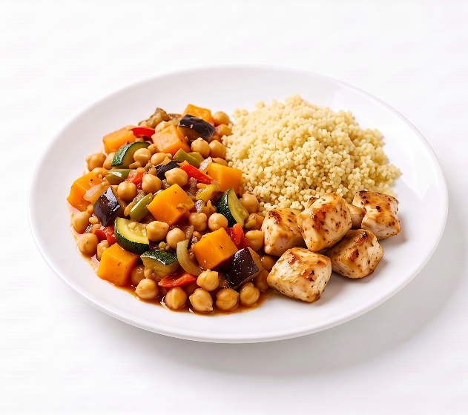 | Chickpea tagine served roasted chicken & couscous
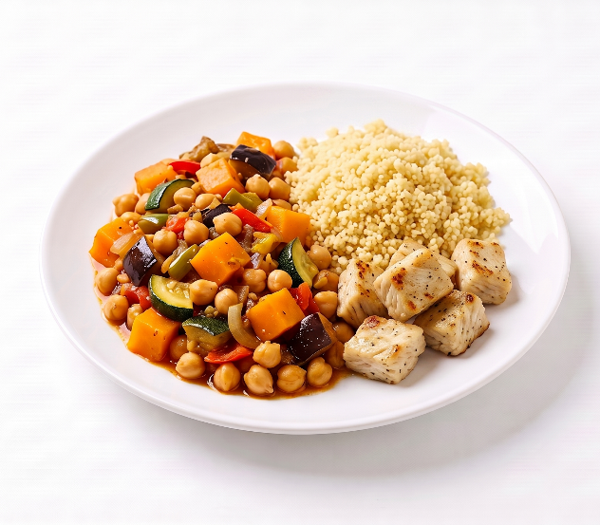 | Chickpea tagine served roasted Quorn & couscous (V)
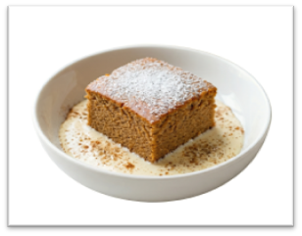 | Carrot cake served with cream (V)  or  Fruit of the day  or  Sugar free jelly

