Lunch Menu
Mains
- Chicken, bean & vegetable stew
Allergens – Milk, wheat & celery
Vegetarian
- Egg, bean & vegetable stew (V)

Allergens –Wheat, egg, milk & celery

Pudding

Pear & ginger cake
served with cream (V)
Allergens – Wheat, egg & milk
or
Fruit of the day
or
sugar free jelly
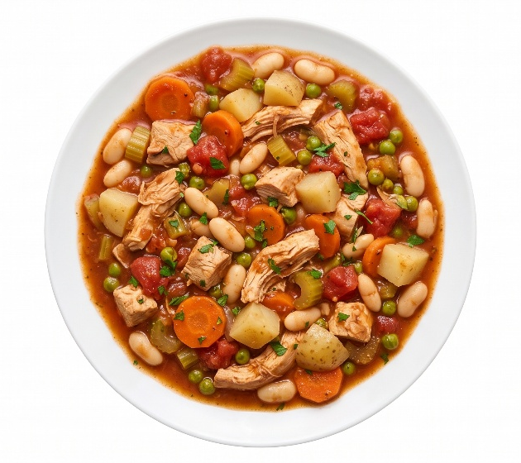 | Chicken, bean & vegetable stew
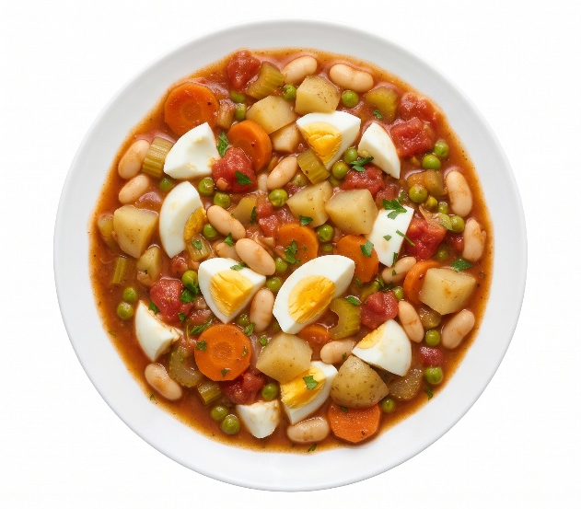 | Egg, bean & vegetable stew (V)
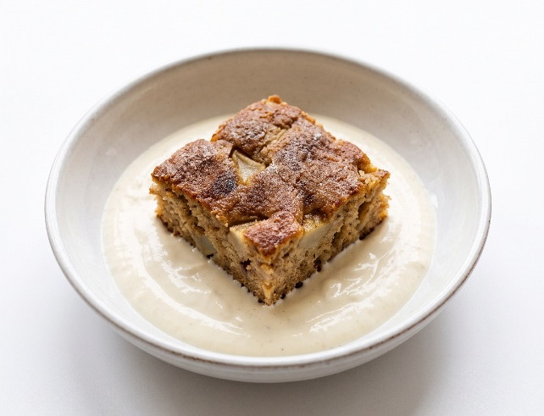 | Pear & ginger cake  served with cream (V)  or  Fruit of the day  or  sugar free jelly

