Lunch Menu
Mains
- Jacket potato served with
beetroot & feta salad
Choose your fillings
- Tuna & mayonnaise
Allergens – Milk, fish, egg, mustard & sulphite
- Baked bean & cheese (V)
Allergens – Milk & sulphite
- Cheese & pickle (V)
- Allergens – Milk, barley & sulphite
Pudding
Raspberry cheesecake (V) or
Allergens –Egg, wheat & milk
Fruit of the day
Or Sugar free jelly
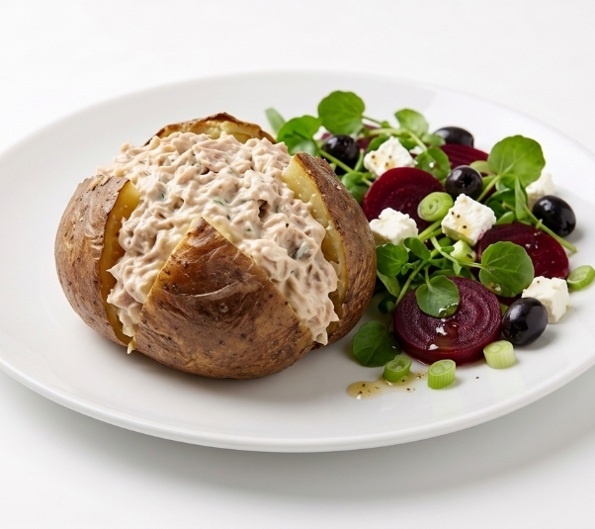 | Jacket potatoes with tuna & mayonnaise served with beetroot & feta salad
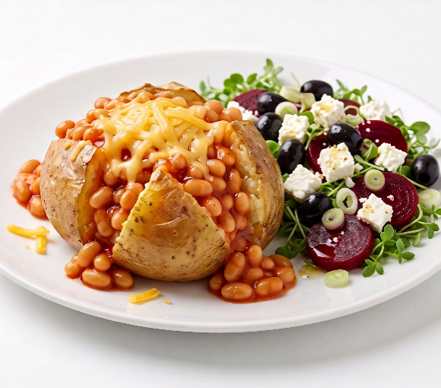 | Jacket potatoes with baked & bean and cheese served with beetroot & feta salad (V)
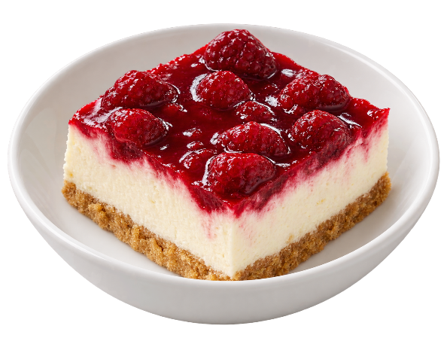 | Raspberry cheesecake (V)  or  Fruit of the day  or  Sugar free jelly

