Lunch Menu
Mains
- Salmon frittata served roasted tomato & garlic bread
Allergens – Wheat, fish, egg, milk & celery
Vegetarian
- Feta cheese frittata served roasted tomato & garlic bread(V)
Allergens – Wheat, egg, milk & celery
or
- Chickpea & vegetable stew with garlic bread (V)
Allergens – Wheat, celery, milk & chickpea
Pudding
- Sticky toffee pudding (V) or
Allergens – wheat, milk & egg
Fruit of the day or
Sugar free jelly or (V)
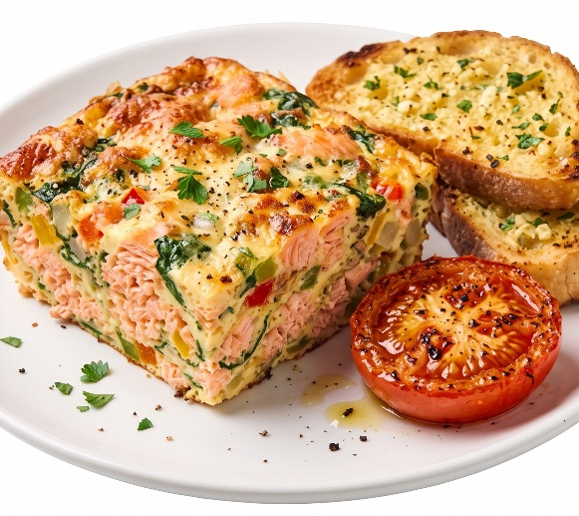 | Salmon frittata served roasted tomato & garlic bread
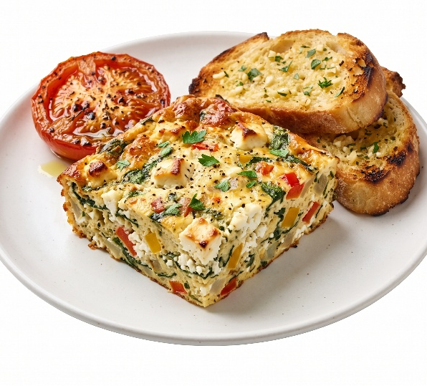 | Feta cheese frittata served roasted tomato & garlic bread(V)
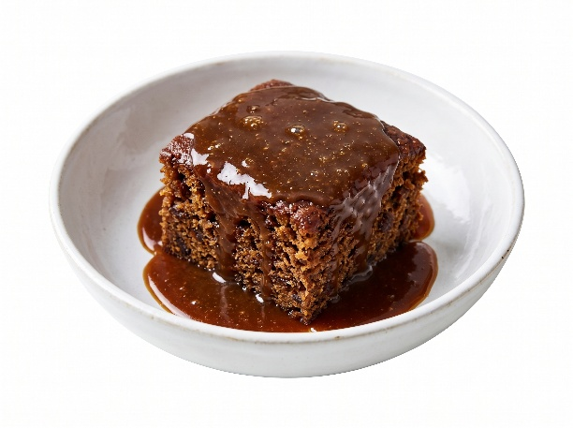 | Sticky toffee pudding (V)  or  Fruit of the day  or  Sugar free jelly

