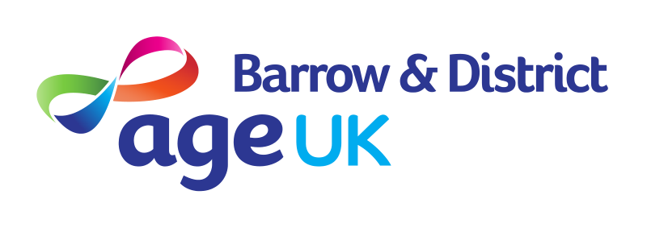

Our Vision
For local people in later life to feel safe, respected, and to have choice and opportunities to lead a life that is enjoyable, meaningful and suited to their individual aspirations

Our Mission
- We will work together with people in later years to offer services, support and education, to help them live healthy, socially active and independent lives.
- Our services and activities will be available throughout the local community, and are provided either free of charge or at the lowest reasonable price.
- We will campaign passionately to remove age as a barrier to opportunity in Barrow and District.

Our Values
- We are proud to work here – we value AUKB, it’s role in making a positive difference and are proud of our ability to make an impact through our work and in our communities
- We care - we are inclusive, we support each other, treat everyone with respect, are accessible and listen & act in the best interests of all
- We go above & beyond - Excellence is the norm, we are only satisfied when we do our best, we strive to go above and beyond in all that we do
- We take responsibility – we value and respect individual and team contribution, taking responsibility for our own actions and their impact
- We innovate - We embrace new ideas, finding better solutions and ways to support our customers

